

**Secondary Street**

**Acceptance Requirements**

**2011 Regulation Edition**

Guidance Document for the

Commonwealth Transportation Board’s

Secondary Street Acceptance Requirements

(24VAC30-92)

December 2018

December 2011



**Secondary Street**

**Acceptance Requirements**

**2011 Regulation Edition**

**Guidance Document for the**

**Commonwealth Transportation Board’s**

**Secondary Street Acceptance Requirements**

**December 2018**

**For further information, contact:**

VDOT District Administrators

Or the VDOT Central Office

1401 East Broad Street

Richmond, Virginia 23219

Copyright 2018, Commonwealth of Virginia



**NOTES:**

The original SSAR was approved by the CTB in March 2009. During the 2011 session, the Virginia General Assembly passed Senate Bill 1462, which became Chapter 870 of the 2011 Acts of Assembly. This action directed the Commonwealth Transportation Board (CTB) and the Virginia Department of Transportation (VDOT) to solicit and consider public comment in the development of revisions to the Secondary Street Acceptance Requirements (SSAR) regulation. This Guidance Document pertains to the 2011 edition of the SSAR regulation which became effective **December 31, 2011**.

Text highlighted in **blue** and underlined are hyperlinks that allow the reader to either move to a place in this document or link to an Internet websites in which additional information on the topic can be found. When reading this document on a computer, the hyperlink can be accessed by placing the mouse pointer over the highlighted item, pressing, and holding down the “Ctrl” key, and left clicking with the mouse.

**Table of Contents**

**Section Page Number**

Regulation Introduction 6

What is the SSAR? 6

Origins of the SSAR – 2009 and 2011 Editions 7

Roles and Responsibilities 9

Approval and Effective Date 10

VDOT Contact Information 10

Revised Provisions for Street Acceptance 12

Overview of Provisions in the 2011 SSAR 12

Public Benefit Requirements 15

Connectivity Requirements 15

Pedestrian Accommodations 35

Plans Governed by the SSAR 46

Applicability, Effective Date and Transition 46

Grandfathering 46

Local Subdivision Ordinances 48

Continuity of the Public Street System 48

Public Service Requirements and Network Additions 51

Public Service Requirements Criteria 51

Network Additions 52

Special Exceptions to Public Service Requirements 52

SSAR Review and Approval Processes 55

Conceptual Sketch Plat 55

Plan of Development Submission 57

Review and Approval Processes 57

Following Plan Approval 58

Street Construction Inspection 59

Street Acceptance Process 60

Phased Development of Streets 63

Criteria for Phased Development of Streets 64

Procedures for Phased Development of Streets 65

Connections to VDOT Maintained Streets 67

Authority and Appeals 69

Discretionary Authority 69

SSAR Appeals 69

Design Requirements and Agreements 72

Right-of-Way Requirements and Related Processes 84

Surety, Fees and Inspections Required 86

Surety 86

Alternatives to Surety 88

Administrative Cost Recovery Fee 89

Street Inspection Fee 90

Inspections and Fees Flowcharts 92

Appendices: Exception form, stub out sign design, agreements, and

technical resources list 95



**Secondary Street Acceptance Requirements**

**Regulation Introduction**

**Secondary Street Acceptance Requirements**

**Guidance Document**

1. **Regulation Introduction**

**A. What is the SSAR?**

The Secondary Street Acceptance Requirements (SSAR) was originally the result of legislation introduced and unanimously adopted during the 2007 session of the Virginia General Assembly.

In recent years, the miles of streets in the secondary system and the level of congestion have both increased while state and federal transportation resources have decreased. The policy and design standards contained within the SSAR are intended to ensure that streets accepted into the state system of highways for public maintenance provide adequate benefit to the public and help to increase the efficiency of the state’s street network.

The SSAR serves as a vital component in the planning, design, and delivery of a street network which will promote livability, a more efficient transportation network, and the creation of more transportation choices. The provisions contained in the SSAR will not by themselves ensure these goals will be met. Instead, careful community planning by localities, cooperation between the involved parties, and thoughtful employment of the various elements of the SSAR are required to achieve these goals.

This SSAR Guidance Document for the 2011 edition of the regulation will assist staff of the Virginia Department of Transportation (VDOT), the development community, citizens, and local governments in the proper development and review of plats and plans, administrative processes, construction inspections, and applicable fees.

The Guidance Document is designed to direct the user through the specific standards and procedures contained within the SSAR. The document is organized in the following manner:

1. Background and origin of the 2009 and 2011 SSAR
2. Roles of VDOT staff and the development community
3. Major provisions in the 2011 SSAR
4. Types of plans governed by the SSAR, effective date, and grandfathering
5. Public service requirements for acceptance
6. Description of the SSAR’s review and approval processes
7. Discussion of the phased development of street lanes
8. Appeal processes contained within the SSAR
9. Street design requirements
10. Required rights-of-way
11. Surety, fees, and inspection processes

**Regulation Introduction**

**What is the SSAR (continued)**

At the time that developers and engineering consulting firms begin projects, they must determine if any proposed streets will be designed to be eligible for acceptance into the state system. Roads designed and constructed to the standards in the SSAR may qualify for acceptance into VDOT’s secondary system of highways for public maintenance. This means that following the appropriate layout, design, construction, inspection, and the payment of fees, VDOT will maintain these new streets.

The SSAR’s requirements apply to all streets intended to be maintained by the department as part of the secondary system of state highways. It should be noted, however that streets constructed using state highway allocations are NOT subject to the requirements of the SSAR.

Developers may also choose to construct streets which do not meet VDOT requirements. These roads will be privately or locally maintained by the developer, a property owners association, or a local government. Such streets may meet the standards of the SSAR at the choice of the developer or as required by local ordinances.

**B.** **Origins of the SSAR – 2009 and 2011 Editions**

The SSAR was developed in response to legislation introduced and unanimously adopted during the 2007 Session of the General Assembly. Chapter 382 of the Acts of Assembly of 2007 added §33.2-334 to the Code of Virginia, which required the Commonwealth Transportation Board (CTB) to develop new standards for the acceptance of streets into VDOT’s secondary highway system. The 2011 SSAR supersedes the 2005 Subdivision Street Requirements (SSR) and the 2009 SSAR. Section 33.2-334 specifically includes three legislative goals which the SSAR must meet. These goals include:

1. Ensuring the connectivity of road and pedestrian networks with the existing and future transportation network
2. Minimizing stormwater runoff and impervious surface area
3. Addressing performance bonding needs of new secondary streets and associated cost recovery fees

These provisions will help ensure that streets built by developers will enhance the overall capacity of the transportation network by providing additional transportation connections to adjacent developments. In the past, many projects had been built with only one way in and one way out of the development. Projects with this type of street network require that all trips – both local and long-distance – use the regional transportation network. Additional transportation connections between adjacent developments will allow local trips to take place on local streets and reduce the burden on the regional transportation network.

**Regulation Introduction**

**Origins of the SSAR – 2009 and 2011 Editions (continued)**

**Benefits of the SSAR Regulation**

* Create a more efficient transportation network
* Improve emergency response times and reduce costs
* Improve safety and access for children, pedestrians and bicyclists
* Encourage appropriate vehicle speeds on local streets
* Reduce stormwater runoff

During the 2011 session, the Virginia General Assembly passed Senate Bill 1462, which became Chapter 870 of the 2011 Acts of Assembly. This Chapter directed the CTB and VDOT to solicit and consider public comment in the development of revisions to the SSAR regulation.

The CTB approved the SSAR revisions in October 2011.  These revisions became effective December 31, 2011.  While there were numerous amendments to the regulation, the following lists the primary differences between the 2009 and the 2011 versions of the SSAR:

1. Elimination of the “connectivity index” requirement
2. Elimination of “area types” which divided the state into three categories with relation to the connectivity index requirements
3. Reduce the median lot size for required pedestrian accommodations and combines this requirement with average daily traffic
4. Require additional external connection(s) when dwelling unit or vehicle per day thresholds are met per network addition (threshold is when a network addition contains over 200 dwelling units or the use generates over 2,000 vehicles per day)
5. Allow the District Administrator’s Designee (rather than the District Administrator) to waive or modify specific and commonly occurring physical situations
6. Reduce the cycle time from 45 calendar days to 30 calendar days for connectivity exceptions and appeals

**Regulation Introduction**

**Origins of the SSAR – 2009 and 2011 Editions (continued)**

VDOT also collected a great deal of public input during 2011 with relation to the revision process. The agency collected comments from April through September during the year and conducted a public information meeting and online broadcast in September to gather additional input. All comments received were reviewed and compiled in the development of the final regulation.

**C.** **Roles and Responsibilities**

There are numerous individuals who are crucial in the land development and street acceptance processes. The following is a list and description of the primary parties:

1. Applicant/Developer – The individual, corporation, or local government who funds the project and submits a plan or plat to VDOT which involves the potential inclusion of streets into VDOT’s secondary highway system for maintenance.
2. Commissioner – The person who is the agency head of VDOT. Certain appeals are submitted to this individual.
3. District Administrator – The individual responsible for the management of one of VDOT’s construction districts. The District Administrator may be called upon during the land development process to interpret SSAR regulations. The SSAR also directs the District Administrator to determine certain appeal requests.
4. District Administrator’s Designee – This individual will be responsible for reviewing plats and plans for compliance with the SSAR, managing the street acceptance process, making initial determinations regarding the interpretation of the SSAR, and is authorized to make final decisions regarding specified waivers and exceptions to the SSAR.
5. Local Government Official – The person or department within the local government who is responsible for the review and approval of site plans.
6. VDOT Central Office – VDOT’s Central Office is accountable for the administration of the secondary street acceptance process. Applicant appeals to the Commissioner are managed through this office.
7. Erosion and Sediment Control Plan Approving Authority – This is generally the local governing body or the state’s Department of Environmental Quality.

**Regulation Introduction (continued)**

**D. Approval and Effective Date**

The Commonwealth Transportation Board approved the 2011 edition of the SSAR at its October 19, 2011 meeting. The effective date of this SSAR was December 31, 2011. There was a transition period from the effective date until February 1, 2012. This transition period is discussed in the “Grandfathering” section of the Guidance Document. Section 30-92-20 of the SSAR regulation, discusses this effective date, the transition period, and how they correspond to different types of plats and development plans.

**E. VDOT Contact Information**

If you would like more information or have additional questions regarding the implementation of the SSAR, please contact your local VDOT District office or consult VDOT’s SSAR page of its website at <http://www.virginiadot.org/projects/ssar/>.



**Secondary Street**

**Acceptance Requirements**

**Revised Provisions for Street Acceptance**

**Revised Provisions for Street Acceptance**

The 2009 edition of the SSAR replaced VDOT’s previous 2005 Subdivision Street Requirements (SSR). Many of the administrative provisions and standards within the SSR are included in both editions of the SSAR.

During 2011, the SSAR was revised in response to the General Assembly’s Chapter 870. This Guidance Document will focus on the contents of the 2011 SSAR, provide direction to assist with the implementation of the SSAR, and discuss the differences between the 2009 and 2011 editions of this regulation.

**A. Overview of Provisions in the 2011 SSAR**

There were a great many revisions made in the 2011 SSAR when compared to the earlier version of the regulation. However, the following lists the major changes between the 2009 and the 2011 versions of the regulation:

1. **Changes to Connectivity Requirements -** During the 2011 revision process, the previous “connectivity index” and “area types” were eliminated from the current SSAR. The following are the major “connectivity” related changes from the 2009 to the 2011 SSAR:
   1. Elimination of the “connectivity index”
   2. Elimination of the SSAR “area types” which divided the state into three categories with relation to the connectivity index requirements; because “connectivity index” was deleted from the regulation, “area types” were also eliminated.
   3. In order to comply with the original Chapter 382 legislation, the SSAR was amended to require additional vehicular connections when a network addition contains over 200 dwelling units or the use generates over 2,000 vehicle trips per day
   4. Amended “failure to connect” to an existing state maintained stub street to eliminate reference to six-year plan impacts; the current SSAR edition allows the District Administrator discretion with relation to such a stub street and if the network addition will be accepted for maintenance by VDOT

With relation to connectivity provisions which have remained consistent in the two SSAR regulations, standards to ensure connectivity of streets between adjacent developments and undeveloped parcels remains in the current SSAR. This provision requires that each network addition has at least two connections. This standard may be waived given certain situations listed in the regulation. The connectivity section begins on page 15 of the Guidance Document and on page 14 of the regulation.

**Revised Provisions for Street Acceptance**

**Overview of Provisions in the 2011 SSAR (continued)**

1. **Reduced Lot Sizes for Required Pedestrian Accommodations** – The median lot size for required pedestrian accommodations have been reduced in response to public input received. The following are the main changes to these requirements:
2. Both Sides of Street - The previous SSAR required pedestrian accommodations on both sides of the street when median lot size for the development was one-half acre or less or a floor area ratio (FAR) of 0.4 or greater or along a collector street with three or more lanes. This has been amended to streets with an average daily traffic count (ADT) over 400 that are located in a development with a median lot size of one-quarter acre or smaller or when the ADT for the street is over 8,000.
3. One Side of Street – This requirement in the 2009 regulation was developments with median lot sizes between one-half acre to two acres , along collector streets with 2 lanes, or if within ½ mile of a school. This standard has been changed to streets with an ADT over 400 that are located in a development with a median lot size between one-quarter acre and one-half acre or when the ADT for the street is between 2,000 and 8,000, or when the street is within ½ mile of a school.

The pedestrian accommodations section begins on page 34 of the Guidance Document and on page 34 of the regulation.

**Revised Provisions for Street Acceptance**

**Overview of Provisions in the 2011 SSAR (continued)**

1. **Appeals to SSAR Requirements** – A variety of appeals, waivers, and the granting of exceptions within the SSAR have been amended. These changes usually relate to distributing the approval authority from the District Administrator to his Designee, reducing the response time for VDOT to reach a final decision, and allowing final decisions to be appealed to the VDOT Commissioner. The following list the primary appeal related changes:
2. Adds the ability for the developer to appeal a District Administrator’s SSAR final decision to the VDOT Commissioner
3. Reduces the amount of time for the District Administrator to make a final decision regarding an appeal from 45 to 30 days
4. Allows the District Administrator’s Designee to make the following decisions:
   * 1. Waive second required access for a network addition when certain situations or conditions exist
     2. Waive additional connection(s) for large network additions
     3. Grant exceptions for general connectivity requirements
     4. Waive or modify pedestrian accommodations when the provisions of the CTB’s policy for bicycle and pedestrian accommodations have been met
5. **Grandfathering Related to “Applicable Former Requirements”** – The ability to design a development pursuant to the requirements of the 2005 SSR or the 2009 SSAR depending upon when VDOT received a completed plat or plan. The following are the timeframes for the two former regulations:
   1. 2005 SSR – Developments submitted before July 1, 2009
   2. 2009 SSAR – Developments submitted between July 1, 2009 and January 31, 2012

Applicability and grandfathering are discussed on page 45 in the Guidance Document and on page 8 of the SSAR.

**Revised Provisions for Street Acceptance (continued)**

**B.** **Public Benefit Requirements** (Page 12 and section 30-92-60 within the SSAR)

Prior to the acceptance of streets or network additions into its secondary system, VDOT must ensure that the proposed streets provide adequate public benefit to warrant perpetual public maintenance. Public benefit requirements promote a positive relationship between the secondary street network, land use, and citizens. Streets must provide connectivity, required pedestrian accommodations, and public service to meet the public benefit requirements.

This section of the Guidance Document will discuss in detail the public benefit requirements related to connectivity, pedestrian accommodations, and public service standards contained within the 2011 SSAR.

When a developer is considering the phasing of a development, care should be taken to ensure that each phase is designed so that it meets the public benefit requirements. This will allow the streets in the each phase of the development to be accepted when they are complete.

**1.** **Connectivity Requirements** (Page 14 and section 30-92-60 within the SSAR)

**a. Introduction to Connectivity**

One of the legislative goals of the SSAR within §33.2-334 is to “ensure the connectivity of road and pedestrian networks with the existing and future transportation network.”

The regulation requires that new developments provide connectivity between adjacent developments and undeveloped parcels. The provision of connectivity can help improve the overall efficiency and capacity of the transportation network. By providing direct and alternative routes, connectivity can help reduce the burden on major roadways and vehicle miles traveled, and improve emergency response times. These additional routes not only provide more direct courses for emergency responders, but also help disperse local traffic and offer multiple approach points for residents in the event of a road closure.

Connectivity can be defined as connections to an existing publically maintained street, adjacent property, or stub outs that will allow for future street connection to an adjacent property. The SSAR recognizes that connectivity is not always feasible and contains exceptions to address these situations.

**Revised Provisions for Street Acceptance**

**Connectivity Requirements – Introduction to Connectivity (continued)**

This section describes connectivity standards and the SSAR’s relevant requirements will:

* Describe what connectivity is and the related benefits
* Provide how it is related to the legislation and the regulation
* Multiple connections requirement
* Additional required connections for larger network additions
* Stub out streets
* Streets defined as “individual streets”
* Connectivity and Access Management conflicts
* Connectivity exceptions
* Answer frequently asked questions related to connectivity

There are a number of street types for which the SSAR’s connectivity requirements do NOT apply which include the following:

* Frontage road or reverse frontage road as defined in the Access Management Regulations (see 24VAC30-73 and SSAR 24VAC30-92-150)
* Streets petitioned for acceptance into the secondary system of state highways through the Rural Addition Program pursuant to §§ 33.2-335 and 33.2-336 of the Code of Virginia
* Streets petitioned for acceptance into the secondary system of state highways through the Commonwealth Transportation Board's Rural Addition Policy provided such streets were constructed prior to January 1, 2012.

The following diagrams demonstrate how the lack of connecting adjacent developments can decrease the efficiency of the street network as well as increase travel times and vehicle miles traveled.

**Revised Provisions for Street Acceptance**

**Connectivity Requirements – Introduction to Connectivity (continued)**

**Benefits of Connectivity**

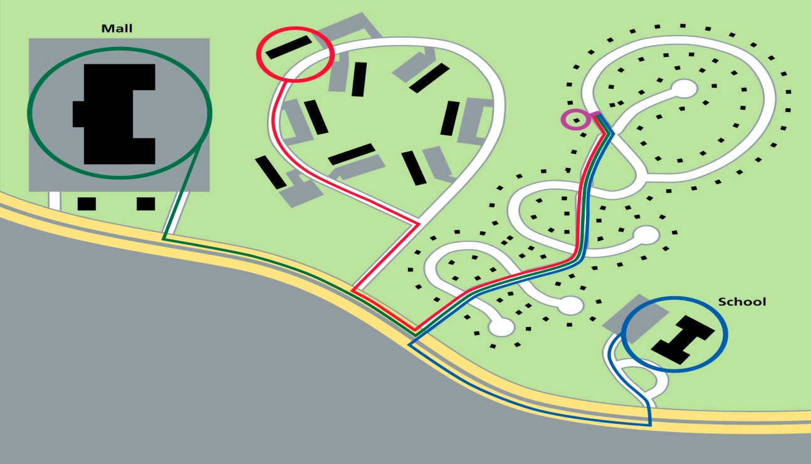

|  |
| --- |
| In the example above, any local trip to a neighbor’s house, the nearby store, or the school would require the driver to access the major highway to arrive at their destination. This design requires that all trips rely on these highways. |

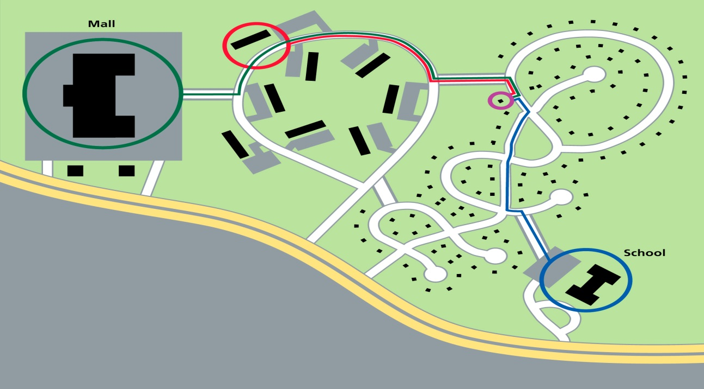

|  |
| --- |
| The goal of connectivity is to provide additional connections between adjacent developments and undeveloped parcels to allow local trips to use local streets. If street connections were built between the developments in the diagram above, trips to the mall, school, and a neighbor’s house would not require the use of the major highway. |

**Revised Provisions for Street Acceptance**

**Connectivity Requirements – Multiple Connections**

**b. Required Multiple Connections and Related Requirements (Page 15 and section 30-92-60 within the SSAR)**

One of the requirements of the SSAR, which has remained consistent within both editions of the regulation, is that all developments will have at least two external connections. These connections should also involve multiple directions whenever possible. This requirement is for individual network additions (phases of a development) regardless of the size or number of lots within the development.

A “connection” in this context mean:

* Physical link with an existing street in the VDOT network (or other publically maintained street, such as a road in a Virginia town or city), or
* Construction of a stub out for a current or future connection, or
* Construction of a stub out to a future network addition within the same development.

It is important to note that a proposed network addition with only one ingress and egress point and with no stub out for future connection may NOT be accepted into the state system as it does not meet the overall connectivity standards contained in the SSAR.

The SSAR does list situations and conditions when the District Administrator’s Designee has the ability to waive or modify this required second connection. In the event that one or more of these situations exist, the Designee may waive this requirement:

1. Adjoining property is:
   1. Completely built out with relation to its current land use,
   2. Its state is such that re-development within 20 years is unlikely, and
   3. There is no stub out either constructed or platted adjacent to the network addition.

When VDOT staff reviews the adjacent property for its “re-development” potential, the major documents the agency will utilize are a combination of the locality’s current comprehensive plan, zoning and subdivision ordinances. VDOT staff should also communicate with the local government’s staff prior to making this final decision to gain additional information pertaining to the county’s land use projections.

**Revised Provisions for Street Acceptance**

**Connectivity Requirements – Multiple Connections (continued)**

1. Adjoining property is zoned for a use whose traffic is incompatible with the use of the property being developed. An example of this could be a retail establishment beside a trucking company. However, in no case shall retail, residential, or office uses be considered incompatible with other retail, residential, or office uses.
2. There is no reasonable connection possible to any adjoining property or adjacent highways due to a factor outside the control of the developer of the network addition. Examples of this could be:
   1. Conservation easements not put in place by the developer of the network addition,
   2. Water features such as rivers, lakes, or jurisdictional wetlands,
   3. Grades in excess of 15% whose total elevation change is greater than five feet,
   4. Limited access highways,
   5. Railroads, or
   6. Government property to which access is restricted.

In the event that a developer wishes to apply for a waiver to the “multiple connections” requirement, he must complete an “SSAR Exception Form” which is located on page 94 of this document.

**Connectivity and Multiple Connections Requirements**

|  |  |
| --- | --- |
| revPage18 | The development with a street network as shown to the left would need to either add an additional connection to an adjacent property or a second connection to the existing street to be accepted into the state system. This proposed development does NOT meet the “multiple connections” requirement. |

**Revised Provisions for Street Acceptance**

**Connectivity Requirements – Multiple Connections (continued)**

**Connectivity Example**

|  |
| --- |
| The example on the left below would meet the SSAR’s “multiple connections” requirement because the development has one physical connection to the existing VDOT street and contains at least one additional connection, in this case to an adjacent property. The example on the right, without either an additional connection (or stub out) to an adjacent property or the existing street network, would NOT meet this requirement.  revPage19a revPage19b |

**Revised Provisions for Street Acceptance**

**Connectivity Requirements – Additional Required Connections for Larger Network Additions**

**c. Additional Required Connections for Larger Network Additions (Page 16 and section 30-92-60 within the SSAR)**

During the 2011 revisions to the SSAR, the connectivity index and corresponding area types were eliminated from the regulation. In order to comply with the “connectivity” goal within the original legislation (“Ensuring the connectivity of road and pedestrian networks with the existing and future transportation network”), the 2011 SSAR needed to add an additional requirement promoting connectivity to balance the deletion of the “connectivity index” in the 2009 SSAR.

This was achieved through the implementation of the “additional connections” requirement for certain network additions. Such additional connections are required when a network addition (the sections of a project which are determined by the developer and for which VDOT accepts for maintenance) is defined by providing direct access to:

* More than 200 dwelling units OR
* Lots whose trip generation is expected to be over 2,000 vehicles per day (VPD)

Streets in these network additions may be accepted into the secondary system if the network addition provides an additional external connection beyond the “multiple connections” requirement in section 2 on page 15 of the regulation for:

* Each additional 200 dwelling units OR
* 2,000 VPD or portion of each over and above the initial 200 dwelling units or 2,000 VPD

The first situation, involving “each additional 200 dwelling units”, refers to a network addition with 201 dwelling units at a minimum. Therefore, if a network addition has between 201 and 399 dwelling units, three connections would normally be required. An addition with between 401and 599 dwelling units would need four connections.

The second type of network addition in this section related to “VPD” generally involves non-residential or mixed-use land use types. In addition to commercial and residential land uses, this VPD method may be used for multi-use or neotraditional developments. In the event this requirement is used, the network addition would need an additional external connection if the projected VPD is over 2,000 or three connections given normal circumstances.

**Revised Provisions for Street Acceptance**

**Connectivity Requirements - Additional Required Connections for Larger Network Additions (continued)**

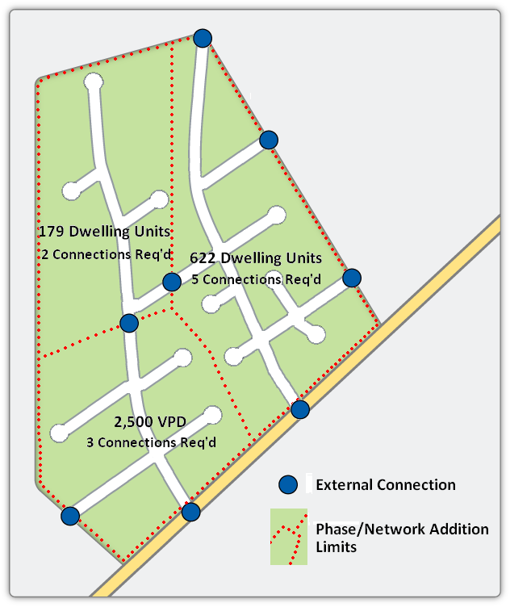

The above example displays a mixed use development with three network additions (each is outlined by the dashed line). This example is used because the “additional required connections” standard within the 2011 SSAR has different requirements for residential and nonresidential/mixed use developments. All connectivity requirements are implemented by network addition.

The network addition to the lower left has a traffic count of 2,500 vehicles per day (VPD). Because this VPD is over 2,000, an additional connection is required (in this case this will be a total of three connections).

The addition to the upper left has less than 200 dwelling units and a VPD lower than 2,000. This specific network addition would be required to construct two connections because it has only 179 dwelling units or less than 200 units.

The network addition to the right has 622 dwelling units. The SSAR states that “for each additional 200 dwelling units or 2,000 VPD or portion of each over and above the initial 200 dwelling units or 2,000 VPD” an additional connection will be required. An addition with 622 dwelling units would be required to provide five connections to existing publically maintained streets or connections to adjacent properties.

**Revised Provisions for Street Acceptance**

**Connectivity Requirements - Additional Required Connections for Larger Network Additions (continued)**

Connections to Collector Roads: For the purposes of the “additional connection” requirement alone, each external connection to a road with a functional classification of “collector” will count as two external connections if both of the two following conditions exist:

* The collector road is an elements of the county’s transportation plan AND
* There is no direct lot access provided to the external collector connection

Similar to the ability of the developer to request a waiver related to the “multiple connections” requirement, the SSAR also allows developers to submit a waiver or modification request for the “additional connection” related to larger network additions. The District Administrator’s Designee should waive or modify this “additional connection” standard if one or more of the following situations renders the provision of such connection impracticable:

1. Adjoining property is:
   1. Completely built out with relation to its current land use,
   2. Its state is such that re-development within 20 years is unlikely, and
   3. There is no stub out either constructed or platted adjacent to the network addition.

When VDOT staff reviews the adjacent property for its “re-development” potential, the major documents the agency will utilize are a combination of the locality’s current comprehensive plan, zoning and subdivision ordinances. VDOT staff should also communicate with the local government’s staff prior to making this final decision to gain additional information pertaining to the county’s land use projections.

1. Adjoining property is zoned for a use whose traffic is incompatible with the use of the property being developed. An example of this could be a retail establishment beside a trucking company. However, in no case shall retail, residential, or office uses be considered incompatible with other retail, residential, or office uses.
2. Developments which have a median density of more than 8 lots per acre (lots sizes of 5,445 square feet or smaller) or with a FAR of 0.4 or higher and where the number of connections provided would be contrary to the public interest. This subsection generally means this requirement may be waived if it will result in to many external access points to create an unsafe situation.

**Revised Provisions for Street Acceptance**

**Connectivity Requirements - Additional Required Connections for Larger Network Additions (continued)**

1. There is no reasonable connection possible to any adjoining property or adjacent highways due to a factor outside the control of the developer of the network addition. Examples of this could be:
   1. Conservation easements not put in place by the developer of the network addition,
   2. Water features such as rivers, lakes, or jurisdictional wetlands,
   3. Grades in excess of 15% whose total elevation change is greater than five feet,
   4. Limited access highways,
   5. Railroads, or
   6. Government property to which access is restricted.

In the event that a developer wishes to apply for a waiver to the “multiple connections” requirement, he must complete an “SSAR Exception Form” which is located on page 94 of this document.

**Revised Provisions for Street Acceptance**

**Connectivity Requirements - Required Connection to Existing VDOT Stub Outs**

**d. Required Connection to Existing VDOT Stub Outs (Page ## and section 30-92-60 within the SSAR)**

If a new development is built which abuts a VDOT maintained stub out, the street network of the new development MUST connect to this stub out for its streets to be eligible for acceptance into the secondary system.

The District Administrator may waive this requirement if the connection to the existing stub out is “unsafe” (see the “Failure to Connect” section for more details related to this issue).

**Failure to Connect to Existing Stub Out Street:** The SSAR states that when a proposed development is located adjacent to a publically maintained stub out “such network addition or individual street must connect to such stub out or stub outs to be eligible for acceptance into the secondary system of state highways” (see SSAR section 30-92-60, C, 1). The regulation continues by adding that the District Administrator “may waive this requirement if the existing stub out is of such design as to make such a connection unsafe.”

There may be instances when the local government approves a site plan or subdivision plat where the streets in the new development do not connect to a publically maintained stub out(s) adjacent to the proposed development.

When this development is NOT connected to an existing VDOT maintained stub out, but meets all of the other public benefit requirements, it will be at the discretion of the District Administrator to determine if this network addition is accepted into VDOT’s secondary system.

**regulation**

# *24VAC30-92-60, C, 7 – Public benefit requirements, Connectivity requirements – Page 19*

*Failure to connect - If a local government approves a subdivision plat for a new development that does not connect to a stub out or stub outs in an adjacent development and such development's network addition or individual street would meet the applicable requirements of this chapter if it connected to a stub out or stub outs in the adjacent development, the network addition or individual street may or may not be accepted into the secondary system of state highways for maintenance pursuant to the authority granted to the district administrators in accordance with 24VAC30-92-100.*

**Revised Provisions for Street Acceptance**

**Connectivity Requirements – Stub Out Streets Described (continued)**

**e. Stub Out Streets Described (Page 15 and section 30-92-60 within the SSAR)**

Required connections can be completed through either a physical link to a publically maintained street or by constructing a stub out street. A stub out connection can be accomplished through three methods which include the following:

* Constructing a stub out to another existing publically maintained stub out located in an adjacent development
* A stub out built to the property line of an adjacent parcel which is intended to be connected in the future and physically is likely to be connected (the District Administrator’s Designee will make this determination)
* A stub out to be connected in the future to a neighboring network addition within the same development

**regulation**

# *24VAC30-92-10 – Definitions – Stub out. Page 7*

*"Stub out" means a transportation facility (i) whose right-of-way terminates at a parcel abutting the development, (ii) that consists of a short segment that is intended to serve current and future development by providing continuity and connectivity of the public street network, (iii) that based on the spacing between the stub out and other streets or stub outs, and the current terrain there is a reasonable expectation that connection with a future street is possible, and (iv) that is constructed to the property line.*

**Stub Out Construction for Future Developments**: The creation of stub out streets at appropriate points in new developments is encouraged. Such stub outs promote the connection of adjoining developments and will result in a more efficient street network.

**Revised Provisions for Street Acceptance**

**Connectivity Requirements – Stub Out Streets Described (continued)**

**Location of Stub Outs**: In the event that a developer selects to construct a stub out, the local official and VDOT staff can assist in this process. The developer and local official should first discuss if the potential location is reasonable for a future connection.

The location of the stub out must be feasible for the future connection to an adjacent land use. In the event that there are multiple potential stub out locations which VDOT finds suitable, the developer will determine which stub out(s) to construct. While this process will be a collaborative effort, the final decision regarding whether the selected location of the stub out is feasible for future connection to the adjacent parcel will be the role of the District Administrator’s Designee during the plan review process.

**Additional Requirements for Stub Out Streets:**

1. Stub outs should not exceed 500 feet in length
2. Stub outs will be constructed to the property line
3. The applicant will post a sign meeting VDOT’s standards. This sign will:
   * Be located adjacent to the nearest newly constructed intersection
   * State that the purpose of the stub out is for a future street connection
   * Be easily visible to adjacent properties and persons using the newly constructed streets
   * The specifications for this sign are located on page 97 of the Guidance Document; there is a sign design for stub out streets adjacent to undeveloped land and another design for infill development.
4. If the terminus of the stub out cannot be seen from the nearest newly constructed intersection, it is recommended that a second sign be located at the end of the stub out.

**Revised Provisions for Street Acceptance**

**Connectivity Requirements – Stub Out Streets Described (continued)**

**Stub Out Street Connections:** When connecting to existing stub outs, especially those stub outs which are excessively wide compared to current design requirements, care must be taken so that such streets do not encourage excessive speed. Generally speaking, for short extensions of stub outs that will tie into other roadways in the new development, no special measures need to be taken. On the other hand, if the stub out will become a lengthy section of street, traffic calming techniques such as bulb-outs can be employed to help ensure appropriate vehicle speed.

The designer and VDOT reviewer need to employ good professional judgment with regards to appropriate measures to control speed. In addition to reduced street widths and design speed, the designer and reviewer may apply traffic calming strategies included in [VDOT’s “Traffic Calming Guide for Local Residential Streets.”](http://www.virginiadot.org/programs/resources/TrafficCalmingGuideOct2002.pdf)

In the event that the existing grade of the parcel being developed is inconsistent with adjacent property, the developer of the initial stub out and corresponding pedestrian facilities should grade appropriately to accommodate the future connection of the stub out and the sidewalks. It is the responsibility of this first developer to ensure a proper grade with which to continue the stub out and sidewalk.

**f. Individual Streets and Connectivity Requirements (Page 17 and section 30-92-60 within the SSAR)**

Streets which are not part of a network addition may meet the requirements of an “individual street.” To satisfy this designation, the local governing body must request that VDOT accept the street in question and that the street meets all applicable design standards. In addition, one termini of the street must include an intersection with an existing publically maintained street and the second termini can either be an additional connection to a publically maintained street OR a stub out to an adjoining property.

A street meeting these requirements will be defined as an “individual street” with relation to connectivity (Section 24VAC30-92-60, C, 4) and does not need to meet the standard connectivity requirements of the regulation. Streets considered for individual acceptance should also be:

* Streets that provide a connection between two existing publicly maintained streets, or
* Streets with a functional classification of Collector or higher

**Revised Provisions for Street Acceptance**

**Connectivity Requirements – Connectivity and Access Management (continued)**

**g. Conflict Between the Connectivity Requirements and Access Management**

There may be instances where [VDOT’s Access Management regulations](http://www.virginiadot.org/projects/accessmgt/default.asp) and the connectivity requirements of the SSAR conflict. If a conflict occurs, the following will apply:

* **Collector Streets** - When the connectivity requirements can only be met through a connection to a collector street that would conflict with the Access Management spacing standards and additional connections to lower order roadways and stub outs are not possible, the entrance spacing standards will be modified by the District Administrator’s Designee to allow for the connection.
* **Minor Arterial Streets** - When the connectivity requirements can only be met through a connection to a street with a functional classification of minor arterial that would conflict with the Access Management spacing standards and additional connections to lower order roadways and stub outs are not possible, the District Administrator’s Designee will either modify the applicable spacing standards to allow for such connection or modify the connectivity requirement.
* **Principal Arterial Streets** - When the connectivity requirements can only be met through a connection to a street with a functional classification of principal arterial that would conflict with the Access Management spacing standards and additional connections to lower order roadways and stub outs are not possible, such developments will have the connectivity requirements modified by the District Administrator’s Designee to accommodate the inability to make this addition connection.

**h. Connectivity Exceptions (Page 17 and section 30-92-60 within the SSAR)**

The connectivity standards contained within the SSAR may be waived or modified. To initiate this process, the project’s developer must submit an “SSAR Exception Form” to the District Administrator’s Designee (this form can be found on page 94 of this Guidance Document).

In addition to this form, the developer must submit all documentation to support the request. All materials must be submitted to both the Designee and the locality’s staff charged with the review of plats and plans.

The Designee is required to contact the developer within 30 calendar days of receipt of the request to advise the developer of his final decision regarding the exception request. For projects where a scoping meeting will be held related to the Traffic Impact Analysis regulations, requests for exceptions and supporting data should be presented and discussed during this meeting.

**Revised Provisions for Street Acceptance**

**Connectivity Requirements – Connectivity Exceptions (continued)**

**Connectivity Exception Process**



**Revised Provisions for Street Acceptance**

**Connectivity Requirements (continued)**

**Frequently Asked Questions: Connectivity**

1. Connectivity and multiple connections: With relation to satisfying the “multiple connections in multiple directions” requirement, can the same state road be used if the egress points are in different directions? Suppose a development can only access the state road in two locations that are in the same direction?

* This will be reviewed on a case by case basis, but generally, the answer will be “yes” regarding the two different directions. If the second connection to the same street is in the same direction as the first connection and it complies with VDOT’s spacing requirements, a second access on the same street can meet this requirement. This will be the ultimate decision of the Designee.

1. Connectivity and local ordinances: What happens if there is a conflict between the SSAR and a local ordinance? For example, what if a local zoning ordinance or Comprehensive Plan restricts connection to an adjacent highway?

* VDOT encourages localities to support the principles of connectivity through all applicable ordinances. In the event that a local ordinance specifically prohibits a connection, the District Administrator may take this into consideration in the process of evaluating an appeal request, but there must be valid technical reasons for the prohibition. VDOT will also consider the ability of a development to meet public benefit requirements through other means.

1. Connectivity and infill areas: Would a development in an “infill” area be a reason for a connectivity exception?

* No, not automatically. The District Administrator’s Designee has the ability to waive or modify connectivity given certain situations listed in the regulation. For infill development, this will most commonly relate to the “Multiple connections in multiple directions standard” and the “Additional connections standard” requirements of the regulation. In the event of an infill area connectivity issue, the developer may want to refer to SSAR section 30-92-60, C, 2 which includes reasons why waivers can be granted to this requirement.

1. Connectivity and modifications: What if wetlands exist along the property boundary with an adjacent parcel?

* A wetland may qualify under the “Water features such as rivers, lakes, or jurisdictional wetlands” situation related to when the District Administrator’s Designee can grant a waiver or a modification to connectivity requirements. If the waiver is not approved, the developer may apply for an exception.

**Revised Provisions for Street Acceptance**

**Connectivity Requirements - Frequently Asked Questions (continued)**

1. Connectivity and Network Additions: If a development is separated by an existing road within the state system, can the development be accepted as one network addition?
   * In the event that an existing street within the state system bisects a proposed development, the existing street splits the development into separate network additions. Within the sketch below, the development would be accepted into the state system as two network additions, one to the south-east and the other to the north-west of the existing street assuming each network addition met the requirements of the regulation.

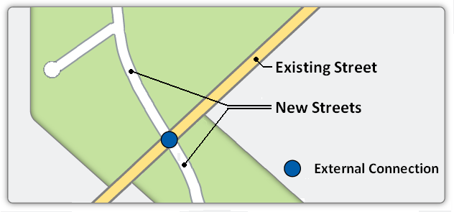

**Frequently Asked Questions: Stub Outs**

1. Stub outs and temporary turnarounds: Under what circumstances will VDOT allow or require a temporary turnaround?

* A temporary turnaround is not required for each stub out street. However, temporary turnarounds should be considered when stub outs are longer than 150 feet. Such turnarounds may be hammerhead, T-type, or traditional circles, depending upon expected traffic, locality requirements, and the developer’s goals.

1. Stub outs and temporary turnarounds: Who will pay for the elimination of the temporary turnaround when a stub out is connected?

* When a temporary turnaround is constructed at the end of a stub out street, the developer who extends, or connects to, the stub out shall incur all of the costs to eliminate the turnaround portion. Any additional curb and gutter required to restore the typical section is the responsibility of the developer who extends or connects to the stub out.

1. Stub outs and public service: Will stub outs be accepted for maintenance without houses located and occupied on them?

* Yes, stub outs are exempt from the “three occupied units” requirements. This is stated on page 13 of the regulation and page 50 in the Guidance Document.

**Revised Provisions for Street Acceptance**

**Connectivity Requirements - Frequently Asked Questions (continued)**

1. Stub outs and pavement design: For developments with stub outs, how should pavement be designed when planning for future traffic?

* Generally, developers will construct the newly built secondary street stub outs to meet “local” street standards.
* Identify the land use and related density designated in the locality’s Comprehensive Plan for the adjoining parcel where the stub out will be connected in the future.
* Contact the locality’s planner to discuss when the Comprehensive Plan is next scheduled to be reviewed or updated. Ask the planner if he/she foresees the Comprehensive Plan being changed regarding the adjoining parcel and the area’s designated land use and density.
* Identify the transportation ingress/egress points most likely to be used by the adjoining parcel in the event that it is developed. Determine how much traffic from the current development may divert through the parcel being connected to.
* Keep in mind that the development on the adjoining parcel will need to make multiple connections to multiple parcels and that traffic will be distributed in several directions.
* If the undeveloped parcel’s proposed land use may lead to the need for a higher order roadway, the developer and VDOT should discuss this issue and verify with the locality the assumptions used to determine the appropriate standard and classification for the streets’ design. *Care must be taken not to require the construction of a collector street when a local street will be sufficient.*
* Design the stub out based upon the given land use, density, projected traffic patterns, projected trips, and the degree that the currently developed parcel will be reasonably impacted when the adjacent parcel is developed.

1. Stub outs and required connection: If a new development is adjacent to a neighborhood with state maintained streets and a “paper” stub out, would VDOT require this connection?

A connection in this instance is not required to meet the "connect to adjacent stub outs" requirement, but connecting to an existing reserved stub out would be an excellent opportunity for a developer and a development to provide an additional external connection to meet connectivity requirements. In the event that a developer utilizes a reserved, but not constructed, stub out, it will be the responsibility of the developer to bear all of the costs to build the entire length of the new street segment to create a physical connection to the existing street network.

**Revised Provisions for Street Acceptance**

**Connectivity Requirements - Frequently Asked Questions (continued)**

1. Stub outs and infill areas: When a new development is built in an infill area, do stub outs which cannot be currently connected count as a multiple connection?

* Yes, much like a stub out constructed to an undeveloped parcel, an infill stub out will count as a connection as long as it is connected to the adjacent property with the greatest potential for redevelopment if this can be predicted. An infill development will be required to meet the same connectivity and public benefit requirements as a non-infill parcel. In the future, the neighboring parcel could be redeveloped, giving the stub out an opportunity to be connected.

1. Stub outs and street acceptance: If the “multiple connections” standard is provided through the construction of a stub street, must the developer wait until the stub is extended to have his subdivision accepted by VDOT?

* No. If the stub out is constructed to the property line and has proper signage stating that it is intended to be connected in the future, the stub out can be accepted before the connection is made.

1. Stub out “paper” streets: Who completes the research to determine if any off-site stub out streets, not constructed yet, exist? What if they are only platted streets on paper?

* It is the responsibility of the developer who is building the stub out to research if there are any platted, but currently unconstructed, stub out streets adjacent to his development.

1. Stub outs and easements: If a stub out crosses an existing utility easement, will a quit-claim be required?

* A quitclaim is required for utility easements on any new street segment that is intended to be taken into the secondary system. More information on this requirement can be found in [VDOT’s “Guide to Additions, Abandonments, and Discontinuances.”](http://insidevdot/C4/Roadway/Document%20Library/Guide%20to%20Additions,%20Abandonments,%20and%20Discontinuances%205A.pdf)

1. Stub outs and vertical connections: What are your responsibilities of the neighboring parcel with regards to grading?

* The developer who originates the stub out must make the connection “reasonable” for the subsequent developer; however, the first developer will not need to grade the adjacent property. This is another reason why special concern should be given in the location of stub out streets. The vertical connection for the stub out must meet minimum VDOT geometric requirements for the specific roadway functional classification of the given road.

**Revised Provisions for Street Acceptance (continued)**

**2. Pedestrian Accommodations** (Page 34 and section 30-92-120 within the SSAR)

The legislative goal related to connectivity applies to pedestrian traffic as well as vehicular trips. This goal is to ensure “the connectivity of road and pedestrian networks with the existing and future transportation network.” To meet this goal, VDOT has amended its requirements for pedestrian accommodations including sidewalks and trails.

During the 2011 revisions to the SSAR, the pedestrian accommodations section was amended a great deal. The two primary changes made involved:

* + Reduction of median lot sizes required to construct pedestrian accommodations
  + Integration of average daily traffic, in addition to lot size, as a factor when requiring pedestrian accommodation

Other factors such, as proximity to public schools and the functional classification of streets, can also impact the pedestrian accommodation requirements. Pedestrian accommodation standards are required only along newly constructed streets and network additions associated with the development. Pedestrian and bicycle facilities should be generally uniform between intersections and are required to be included in the initial construction of the street prior to VDOT acceptance.

All SSAR related pedestrian accommodations within the VDOT right-of-way must meet Americans with Disabilities Act requirements. Developers are also expected to meet all applicable national standards when designing pedestrian facilities. Noncompliant facilities (those that do not meet VDOT standards) outside of VDOT right-of-way must meet all applicable standards as determined by the locality.

VDOT will review the detailed plans for pedestrian accommodations within the VDOT right-of-way, but in general will not complete a detailed design review of those facilities outside of the right-of-way. The locality is expected to complete the design review of noncompliant facilities outside of VDOT right-of-way.

There may be instances regarding pedestrian accommodations when multiple requirements will apply to a given street. In these situations, the greater accommodation requirement shall apply.

In all developments which require the construction of pedestrian accommodations, these facilities shall connect with adjacent existing pedestrian accommodations as may exist and will also allow for connection to future pedestrian facilities located on adjacent parcels.

**Revised Provisions for Street Acceptance**

**Pedestrian Accommodations (continued)**

This description of SSAR pedestrian requirements will:

* + Provide a description of what type of accommodation is required
  + Explain and discuss equivalent pedestrian accommodations
  + Include a flowchart to assist in determining if development will be required to construct pedestrian accommodations (page 39)
  + Discuss the appeal process related to pedestrian accommodations

**Pedestrian Standards**

**a. Higher Density and Traffic Developments – Both Sides of Street**

In the pedestrian accommodations context, “higher density and traffic developments” are defined as those with:

* Streets with an average daily traffic count (ADT) over 400 AND a median lot size of one-quarter acre or smaller, or
* Streets with an ADT over 8,000

For these developments, pedestrian accommodations must be provided on both sides of the street or alternate provisions made that provide equivalent pedestrian mobility.

**b. Medium Density and Traffic Developments – One Side of Street**

For the purposes of pedestrian accommodation requirements, “medium density and traffic development” is defined as projects with:

* Streets with an average daily traffic count (ADT) over 400 AND a median lot size between one-quarter and one-half acre, or
* Streets with an ADT between 2,000 and 8,000

These developments must provide pedestrian accommodations along at least one side of the street or an equivalent pedestrian mobility system.

**c. Low Density and Traffic Developments**

Developments which have an ADT less than 400 and median lot sizes greater than one-half acre are not required to construct pedestrian accommodations unless a subsection below requires the building of such facilities.

**Revised Provisions for Street Acceptance**

**Pedestrian Accommodations (continued)**

**d. Developments near Public Schools**

Regardless of lot size or ADT, there are unique pedestrian accommodations required when new developments are located near a public school facility. This distance is:

* Within one-half street centerline mile of a public school.

These developments will be required to provide pedestrian accommodations along at least one side of the street or provisions made that provide equivalent pedestrian mobility. For developments which are required to meet the “high density and traffic” standards described in subsection (a) above, pedestrian accommodations must be located on both sides of the street.

When a developer constructs pedestrian accommodations related to this subsection, such accommodations will only be required along newly built streets associated with the development. Pedestrian accommodations are not required to be built to the school property unless the development extends to the school property.

**e. Stub Out Connections and Pedestrian Accommodations**

Developers are required to plan and construct subdivisions and developments to connect to the existing stub out streets within adjacent properties. In instances where the stub out has accompanying pedestrian accommodations, the newly constructed street will be required to provide similar pedestrian accommodations. The District Administrator’s Designee will make the determination as to what will constitute “similar” in these situations.

**f. Collector and Arterial Roads with Three or More Lanes**

Collector and arterial roads with three or more through lanes must be designed in the following manner:

* Pedestrian accommodations shall be located on both sides of newly constructed streets, or provisions made that provide equivalent pedestrian mobility.
* Sidewalks may be located immediately adjacent to the street only if they are at least eight feet wide. Tree wells must also be provided in these circumstances
* Retrofitted streets being upgraded to meet VDOT standards can have sidewalks less than eight feet in width if right-of-way is not available to meet the current standard

**Revised Provisions for Street Acceptance**

**Pedestrian Accommodations (continued)**

**g. Connections with Adjacent Parcels**

All newly constructed developments requiring pedestrian accommodations and which are adjacent to existing pedestrian accommodations must connect to these sidewalks, paths, or trails. Such accommodations shall connect with existing pedestrian accommodations and allow for connection to future pedestrian accommodations to adjacent parcels. In the event that a developer is constructing a pedestrian accommodation stub out, it is the responsibility of the developer to properly grade the parcel in order to make the connection with a future pedestrian accommodation feasible to the subsequent developer’s land.

**h. Multi-use Trails/Shared Use Path Criteria**

Pedestrian accommodations are usually located within the street’s right-of-way. If these facilities meet all of VDOT’s related requirements, the agency will accept and maintain these accommodations. Sidewalks will be constructed in accordance with the Subdivision Street Design Guide, while bicycle facilities and shared use paths shall be built in accordance with VDOT’s Road Design Manual.

In some instances, pedestrian accommodations may be located outside of the street’s right-of-way. The agency will not maintain pedestrian accommodations located outside of its right-of-way. In these circumstances, VDOT will enter into an agreement with the locality which will describe how the locality will maintain the pedestrian accommodations.

**i. Noncompliant Pedestrian Accommodations**

Pedestrian accommodations which are not built to VDOT standards will be considered noncompliant unless a design waiver and/or exception has been granted by VDOT. Noncompliant facilities do not quality for VDOT maintenance.

If noncompliant pedestrian accommodations are located within the dedicated right-of-way of the street, a land use permit must be issued by the District Administrator’s Designee. The permit will directly state the parties’ responsibility for maintenance of the accommodations. The permit applicant must be an entity that can assure ongoing maintenance. This entity is commonly, but not solely limited to, the local government.

**Revised Provisions for Street Acceptance**

**Pedestrian Accommodations (continued)**

**j. Pedestrian Accommodations and VDOT Right-of-Way**

In order for VDOT to maintain pedestrian accommodations, these facilities must be located within VDOT’s right-of-way. In the event that a developer constructs accommodations outside of the right-of-way, VDOT would enter into an agreement with the locality. This agreement will discuss how the locality will maintain the accommodations. Agreement forms are located on pages 99 and 101 of the Guidance Document. A dedication or easement for public use would be given to the locality so that public access and maintenance of the accommodations can be assured.

**k. Modification to Pedestrian Accommodation Requirements**

The District Administrator’s Designee may waive or modify the SSAR’s pedestrian accommodation requirements. This process can only be used in situations when the pedestrian accommodation exception provisions of the Commonwealth Transportation Board's policy are met. This policy is titled “[VDOT Policy for Integrating Bicycle and Pedestrian Accommodations” and was last approved by the CTB in 2004](http://leg5.state.va.us/reg_agent/frmView.aspx?Viewid=49767002156~1&typ=0%20&actno=002156&mime=application/pdf).

**SSAR Pedestrian Accommodations Requirements**



**Revised Provisions for Street Acceptance**

**Pedestrian Accommodations (continued)**

**l. Alternative Equivalent Pedestrian Accommodations**

The SSAR allows developers to propose alternative pedestrian accommodations in place of the standard requirement contained in the regulation. The alternative accommodation must provide equivalent pedestrian mobility as approved by the District Administrator’s Designee. Factors to consider when proposing and evaluating an alternative pedestrian accommodation include but are not limited to the following:

* Alternative accommodations should, in aggregate, meet or exceed the level of service and connectivity that would have otherwise been achieved by the standard requirement.
* Consideration should be given to the benefit that the proposed alternative pedestrian accommodation provides to the surrounding pedestrian network. This would include consideration of the location of pedestrian generators and receptors like transit stops, parks, schools, stores, neighborhoods, or other public properties.
* Alternative accommodations should not measurably increase the exposure of pedestrians to vehicle traffic and safety related concerns. Issues to consider include traffic volumes, vehicular operating speeds, available sight distance, and the location of potential pedestrian crossing points to name a few.

The following examples have been prepared to help illustrate how these factors should be considered during the evaluation of alternative pedestrian accommodation proposals.

**Revised Provisions for Street Acceptance**

**Pedestrian Accommodations (continued)**

**Alternative Equivalent Pedestrian Accommodations**

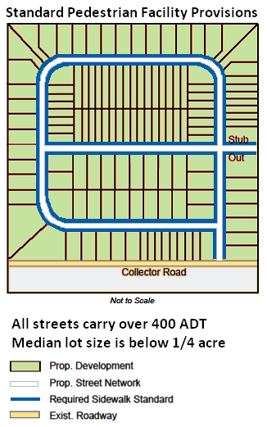

The first example to the left shows a proposed network addition with an ADT and median lot size which requires sidewalks on both sides of the street. This development meets the specific pedestrian accommodations requirements of the SSAR.

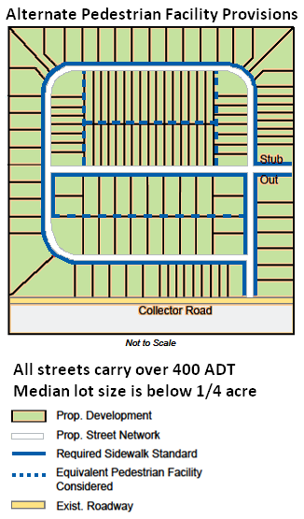

This example shows a possible alternative approach. This proposes the accommodations for a portion of the development to be provided at the rear of the lots instead of along the street. This could be a sidewalk or a shared use path. Because it provides a reasonably equivalent connection to the lots within the development and to the surrounding pedestrian network, it would likely be approved as an acceptable alternative accommodation. While the streets in this example could serve through movements, the proposed development does not have accommodations on both sides. This is more than offset by the improved safety that pedestrians could have when traveling to the area’s pedestrian traffic generators. Based on the presence of accommodations along one side of the streets together with the expanded network of accommodations provided along the existing roads, it is likely that the alternative proposal would be approved as an acceptable alternative.

**Alternative Equivalent Pedestrian Accommodations**

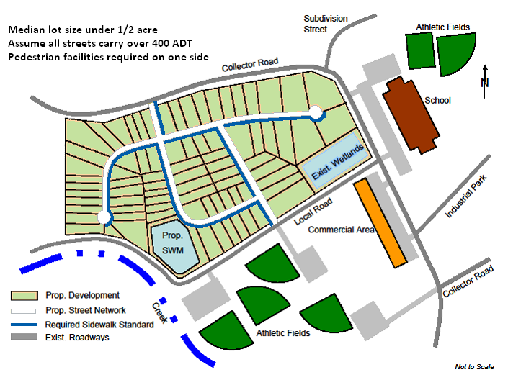

The examples on this page displays a development in which accommodations are required on one side of the street. The diagram above shows compliance with the SSAR’s specific requirements.

The diagram below shows the same development with “equivalent pedestrian accommodations.” Some streets no longer have sidewalks adjacent to the streets, but a trail or path system has been constructed to enhance the pedestrian network within the development. This new system also provides increased pedestrian access to neighboring attractions such as the school and the athletic fields.

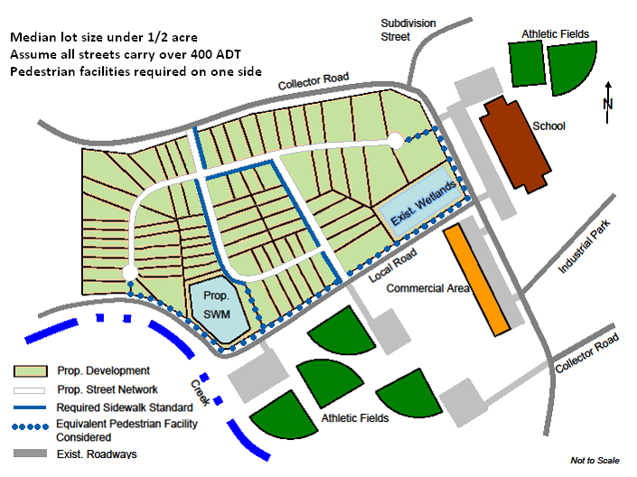

**Revised Provisions for Street Acceptance**

**Pedestrian Accommodations (continued)**

**L. Appeals to Pedestrian Accommodation Requirements**

The District Administrator’s Designee may waive or modify the pedestrian accommodations within the SSAR.

These exceptions may be granted in situations when the provisions of the Commonwealth Transportation Board's "Policy for Integrating Bicycle and Pedestrian Accommodations" are met.

**Frequently Asked Questions: Pedestrian Accommodations**

1. If a network addition has a median lot size of less than one-quarter acre lots, but no street has an ADT over 400, are pedestrian accommodations required?

* No, not unless the addition involves a collector or arterial street with three or more lanes (accommodations on both sides of street) or within one-half centerline mile of a public school (accommodations on one side of street).

1. What pedestrian accommodations are required if lots size and ADT require accommodations on both sides of the street, but the vicinity from a public school only requires accommodations on one side of street?

* Pedestrian accommodations will be required on both sides of the street unless accommodations for equivalent pedestrian mobility are approved by the District Administrator’s Designee. This is the case because section 30-92-120, I, 1 of the regulation (on page ## of the SSAR) states that “if multiple requirements apply to a street, the greater accommodation requirement shall govern.”

1. If a network addition has a median lot size between one-quarter and one-half acre lots, but not all streets in the network addition has an ADT over 400, where will pedestrian accommodations be required?

* Unless required by another subsection of the SSAR, pedestrian accommodations would only be required on those streets where the ADT is over 400.

1. Will pedestrian accommodations be required for streets with an ADT over 8,000 if the development involves large (over one-half acre) lots?

* Yes, pedestrian accommodations would be required on both sides of this street.



**Secondary Street**

**Acceptance Requirements**

**Plans Governed by the SSAR**

1. **Plans Governed by the SSAR**

**A.** **Applicability, Effective Date, and Transition** (Page 8 and section 30-92-20 within the SSAR)

The purpose of the SSAR is to provide regulations for the planning, design, development, and acceptance of newly constructed streets intended to be maintained by VDOT and taken into the Commonwealth’s secondary street network. The SSAR, along with other corresponding VDOT documents such as the Road Design Manual, provides the minimum criteria for streets to qualify for addition to the secondary system.

The effective date of the 2011 version of the SSAR was December 31, 2011. The period from the SSAR effective date to February 1, 2012 is the transition period for the SSAR. During this period, developers are able to submit qualified plats and plans to VDOT which follow the standards of the applicable former requirements. Beginning on February 1, 2012, all complete plats and plans INITIALLY submitted to the local government and to VDOT must meet the requirements of the 2011 SSAR.

With relation to the “grandfathering” of plats and plans, the 2011 SSAR contains a definition and description for “applicable former requirements.” This term relates to the requirements for which the development will need to meet depending upon when the development is submitted. The corresponding requirements and submission periods are as follows:

* 2005 Subdivision Street Requirements (SSR) for developments submitted prior to July 1, 2009
* 2009 edition of the SSAR for developments submitted between July 1, 2009 and January 31, 2012

**B. Grandfathering** (Page 9 within the SSAR)

The purpose of the “Grandfathering” section is to establish which plats and plans will be governed by the previous requirements. This discussion of Grandfathering will:

* Explain which plans can be submitted under the standards of the SSR and the 2009 SSAR requirements
* Define how long plans will be valid under the previous regulations

**Plans Governed by the SSAR**

**Grandfathering (continued)**

Below are the categories of plats and plans that will be governed by the applicable former requirements:

1. Street Layout Proffered prior to February 1, 2012 – Such proffered street network layouts must have been approved/accepted by the local governing body prior to February 1, 2012. This proffering would have involved receiving all required zoning approvals from the local governing body in order to construct the proposed development. In order for this category to be utilized, the general layout of the street(s) as proffered must be binding and not able to be modified through the site plan process.

Only related to this provision for “proffered street layout,” the grandfathering shall not be lost or impacted due to a modification of the relevant plan or plat as long as the development:

* Retains 80% of the proffered street centerline mileage; or
* Adds up to 20% additional street centerline mileage; or
* Involves a combination of changes so that no more than a total of 20% of the street centerline mileage is added, modified, or deleted; and
* The land use is not expected to result in an increase of traffic generation.

1. Streets included within a recorded plat or valid final site plan prior to February 1, 2012
2. Valid preliminary plat, construction, site, or final plans approved prior to February 1, 2012 may follow the applicable former requirements for up to five years or longer if the plat/plan remains valid under all applicable laws
3. Street construction plans approved by VDOT prior to February 1, 2012

Regarding the aforementioned grandfathered plats and plans, the applicant may select to follow the “applicable former requirements” or the 2011 SSAR standards. In the event the applicant chooses to abide by the 2011 SSAR regulations, this decision should be communicated to the local government official and VDOT staff prior to the submittal of the development’s plat or plan.

In the event that a request is made by the applicable locality, the “applicable former requirements” shall apply to the development if the applicant has submitted at a minimum a conceptual sketch that includes all of the elements required under 24VAC30-92-70 A (see page 19 of the regulation and page 54 of this Guidance Document) prior to February 1, 2012. However, the above four types of plats and plans shall take precedence over this grandfathering provision in any instance of a conflict.

**Plans Governed by the SSAR (continued)**

1. **Local Subdivision Ordinances** (Page 11 and section 30-92-30 within the SSAR)

If a locality administers a land development related ordinance which includes regulations different than the SSAR AND the local regulations do not conflict with the SSAR, those local requirements will be applied to new developments.

1. **Continuity of the Public Street System** (Page 12 and section 30-92-40 within the SSAR)

Continuity of VDOT’s transportation network is a simple but crucial concept when a developer is planning the construction of a new street. Streets intended to be built to VDOT standards and maintained by the agency must be connected to an existing street within the VDOT system or joined to an existing city, town, or publicly maintained county street. Without this connection, there is not continuity of the street system and the network addition or individual street will not be accepted by VDOT into its system for maintenance.

**Frequently Asked Questions: Grandfathering**

1. Grandfathering and rezoning: Would a conceptual sketch plat used for rezoning qualify for grandfathering?

* In the event that the following three requirements are met, the plat would be grandfathered and could meet the applicable former requirements:
  1. A “complete” conceptual sketch plat and its attendant information, as defined by the SSAR regulation, is submitted,
  2. The locality accepts the sketch plat and requests that VDOT consider it to be governed by the applicable former requirements, AND
  3. The complete sketch plat must be submitted to the locality and to VDOT prior to February 1, 2012.

1. Grandfathering: What happens when a Planned Development under a zoning application has already been approved, but not constructed?

* In the event that the plat is defined as one of the four types which has received grandfather status within the SSAR and the plat remains valid under §15.2-2261 of the Code of Virginia, the streets can be constructed using the applicable former requirements. In order for plans to be grandfathered, the layout of the streets cannot be able to be modified through the site plan or subdivision plat process, unless done so as allowed only under the “proffered street layout” provisions.

**Plans Governed by the SSAR**

**Grandfathering (continued)**

1. Grandfathering: If a plan has been submitted, but not approved, will it need to be revised to meet the new requirements?

* It will depend on the condition and status of the plat or plan. For example, an incomplete sketch plat could be submitted, but if it is not complete, it would not be grandfathered. Generally, plats or plans which have progressed past the “complete conceptual sketch plan” stage should be grandfathered.

1. Grandfathering: How will VDOT address preliminary/tentative subdivisions designed under the applicable former requirements and reviewed (provided formal written comments) but have not been approved prior to February 1, 2012?

* VDOT may consider such plats for grandfather status, but the locality would need to concur and request that VDOT accept the plat under the applicable former requirements.



**Secondary Street Acceptance Requirements**

**Public Service Requirements and Network Additions**

**4) Public Service Requirements and Network Additions**

**A.** **Public Service Requirement Criteria** (Page 12 and section 30-92-60 within the SSAR)

In order for VDOT to accept a proposed street into its system, each phase of a development or “network addition” must meet the approved public service requirements.

If a developer is unsure if a potential development or network addition meets these requirements, the developer is encouraged to contact the local VDOT district office to verify that the standards have been met.

For example, VDOT will not accept a street into its system if it only serves two dwelling units because that would traditionally be considered a shared driveway. To be considered for inclusion into VDOT’s secondary street network, additions must meet one or more of the following criteria:

1. Serves three or more occupied units with a unit being defined as one of the following:

* Single-family residence
* Owner-occupied apartment
* Owner-occupied residence in a qualifying manufactured home park. Streets serving manufactured home parks may only be considered when the land occupied by the manufactured home is in the fee simple ownership of the residents of such manufactured home
* Stand-alone business or a single business entity occupying an individual building or similar facility

1. A street connecting a segment between two streets that meet one of the public service requirements or are existing publicly maintained streets
2. Stub out street
3. Serves as an access to schools, churches, public sanitary landfills, transfer stations, public recreational facilities, or similar facilities open to public use

**Public Service Requirements, Individual Streets and Network Additions**

**Public Service Criteria (continued)**

1. Serves at least 100 vehicles per day generated by an office building, industrial site, or other similar nonresidential land use in advance of the occupancy of three or more such units of varied proprietorship. In such instances, a developer will submit traffic count data to verify this 100 or more figure that exists prior to the location and occupancy of the three or more units. Any addition under this provision shall be limited to the segment of a street that serves this minimum projected traffic and has been developed in compliance with these requirements.
2. Included in the network of streets envisioned in the transportation plan or element of a locality’s Comprehensive Plan that, at the time of acceptance, serves an active traffic volume of at least 100 vehicles per day
3. Multifamily, townhouse and retail shopping complexes meeting the following requirements:

* A through street that serves a multifamily building may be considered for maintenance if it is deemed by the department to provide a public service, the street is well defined, and the District Administrator’s Designee determines that it is not a travel way through a parking lot
* Entrance streets and the internal traffic circulation systems of retail shopping complexes qualify if more than three property owners are served and the District Administrator’s Designee determines that the street is not a travel way through a parking lot.

**B.** **Network Additions**

Network additions qualify for acceptance into VDOT’s secondary system if each street within the addition meets at least one of the “Public Service Requirement” criteria listed above for an “individual street.” Such additions will be considered to provide adequate public service if each street within the addition meets one or more of the requirements for “individual streets” listed above.

**C.** **Special Exceptions to Public Service Requirements**

In the event that a developer is unsure if the proposed streets and development meet the specific public service requirements listed above, the developer may submit a request for clarification in writing to the District Administrator’s Designee.

There may be situations in which an applicant’s proposed street(s) or network addition(s) does not specifically meet the public service requirements of the SSAR, but do meet the general intent of the regulation. In these circumstances, the applicant’s request for clarification may actually be a request for a special exception. The chart below describes this process.

**Public Service Requirements, Individual Streets and Network Additions**

**Public Service Criteria (continued)**

The VDOT Exception Request Form is located on page 94 of the Guidance Document.

**Special Exceptions to Public Service Requirements Process**





**Secondary Street**

**Acceptance Requirements**

**SSAR Review and Approval Processes**

**5)** **SSAR Review and Approval Processes** (Page 19 and section 30-92-70 within the SSAR)

There are specific processes which must be completed in order for proposed developments to be accepted into VDOT’s secondary street system. These requirements and processes are dependent upon the type of plat or plan being submitted. The following sections will describe these processes and the primary requirements for each.

**A. Conceptual Sketch**

The purpose of the conceptual sketch is for local officials and VDOT staff to review the proposed development for entrance requirements, basic street layout, street classifications, and the overall transportation facilities plan for the development. This sketch should include enough detail to determine the appropriate functional classification of the proposed street(s), and if connectivity and pedestrian accommodation requirements have been met. The following information should be contained within the conceptual sketch:

1. The general location, vicinity, and configuration of planned streets, including the terminus of each street and the traffic volume anticipated when the land served is fully developed for the proposed land uses;
2. The location, area, and density or FAR of each type of proposed land use within the development;
3. The general location of any proposed transportation facility including any public transportation facilities as well as bicycle and pedestrian accommodations within the development's boundaries included in the Comprehensive Plan of the governing body;
4. The proposed functional classification for each street in the development;
5. The connectivity requirements for each network addition;
6. The location of stub outs on adjoining properties and the existing land use of the adjacent properties;
7. Any waiver or modification requests made related to the SSAR’s connectivity requirements;
8. General preliminary information on the type of any storm sewer system, such as BMP, outfalls, or conveyance channels, that is proposed to be located within the right-of-way as described in 24VAC30-92-120 L 2 and whether the project is located in a MS4 regulated area or a TMDL watershed;
9. Any other available information pertinent to the intended development.

**SSAR Review and Approval Processes (continued)**

**Conceptual Sketch Review Process**

The following chart describes the process for the review and approval of a conceptual sketch submitted to VDOT.



**SSAR Review and Approval Processes (continued)**

**B. Plan of Development Submission**

The applicant will submit the pertinent development plans to the local government official as well as the District Administrator’s Designee. If availability allows, VDOT staff may review the plans for developments not intended to be accepted into the secondary system but are constructed to the SSAR requirements. In these situations, VDOT can recover the costs related to this review (see “Surety and Fees” section for more details).

**C. Review and Approval Processes**

Once plats and/or plans are received by VDOT, the District Administrator’s Designee will evaluate the documents to determine the appropriate reviews and related personnel required to analyze the proposed development. The Designee will arrange for these reviews to be completed. The specific time requirements for VDOT to review plats and plans are included in §§[15.2-2222.1](http://leg1.state.va.us/cgi-bin/legp504.exe?000+cod+15.2-2222.1) and [15.2-2260](http://leg1.state.va.us/cgi-bin/legp504.exe?000+cod+15.2-2260) of the Code of Virginia.

The Designee will inform the local government official and the developer about the results of the reviews performed and if the plans are in compliance with all applicable VDOT regulations and any pertinent standards included in the regulations incorporated by reference in the SSAR. VDOT’s approval of construction plans will expire five years after approval if construction has not started. The review process will result in either the finding that the plans are in compliance or that revisions will be required. The following describes the general processes for both possibilities:

**SSAR Review and Approval Processes**

**Review and Approval Processes (continued)**

**Plans in Compliance with Regulations:**

1. The VDOT Designee will send a letter to the developer and the local government official which confirms that the plans are in compliance with applicable VDOT requirements and that the developer may obtain a Land Use Permit to establish the developer’s connection(s) to the existing VDOT road.
2. This letter denotes VDOT’s approval of the street layout and design indicated and described within the submitted plans
3. Any subsequent revisions, additions, or deletions to the approved plans shall require specific written approval from the VDOT Designee before the development can proceed

**Revisions Required to Submitted Plans:**

1. The District Administrator’s Designee will provide a written list of required changes to the local official and the developer
2. The developer will revise the plans to comply with all the items contained within the District Administrator’s Designee’s letter, VDOT regulations, and all documents incorporated by reference within the SSAR
3. The developer submits revised plans to the local government official and the District Administrator’s Designee for subsequent review

**D. Following Plan Approval**

The District Administrator’s Designee letter constitutes VDOT’s commitment to ultimately accept the proposed streets or network additions included within the approved plans when the roads are constructed to all applicable requirements.

In the event that VDOT discovers or is informed that unapproved changes have been made during the construction phase, VDOT will assess whether these changes impact the eligibility of the road’s future acceptance into the secondary highway system. The VDOT Designee will determine if the changes have a possible negative effect on public benefit, public safety, or the physical integrity of the roadway, right-of-way, adjacent property, or facilities governed by VDOT. If it is determined that the changes will have a negative impact or that the changes conflict with the provisions of the SSAR, VDOT may refuse acceptance of the street or network addition until the situation(s) is corrected

VDOT’s approval of street construction plans expire five years after approval if construction has not begun (this period has been extended from three years in the Subdivision Street Requirements). If this time period has expired, the developer must resubmit the plans for subsequent reviews and approval.

**SSAR Review and Approval Processes (continued)**

**E. Street Construction Inspections**

Upon approval of the construction plan, but prior to street construction, the District Administrator’s Designee should advise the applicant about the procedures for inspection of the construction phases and the scheduling of those inspections. VDOT inspection of each of the following construction phases is highly recommended:

1. Installation of any enclosed drainage system before it is covered
2. Installation of any enclosed utility placements within the right-of-way before being covered
3. Construction of the cuts and fills, including field density tests, before placement of roadbed base materials
4. A final pavement design, based on actual soil characteristics and certified tests, shall be completed and approved before the pavement structure is placed
5. Placement of base materials, including stone depths, consistent with the approved pavement design, prior to placement of the paving course or courses, followed by field density and moisture tests and the placement of a paving course as soon as possible
6. Construction of pavement, including depth and density, upon completion as part of the final inspection

Prior to the final street acceptance process, all signs for the development will be reviewed, located, and approved by VDOT. The signing plan should be part of the plan approval at the inset of the project. This plan will clarify who is financially responsible for the signage fabrication and installation. Signs designated for parking and parking restrictions may or may not be needed; this will be based upon locally adopted ordinances if the locality administers such regulations.

**SSAR Review and Approval Processes (continued)**

**F. Street Acceptance Process**

Following VDOT staff certification that the street(s) has been constructed in a manner consistent with the VDOT approved plans and compliant with all applicable regulations, VDOT will inform the local government of the agency’s readiness to accept streets. The local governing body, in consultation with the Designee, will initiate the street’s acceptance into VDOT’s secondary system, provided the following conditions are met:

1. The developer has dedicated the necessary public right-of-way to public use
2. All streets proposed for acceptance have been constructed to all applicable standards and are consistent with the plats and plans approved by VDOT
3. Streets meet the required public benefits included within the SSAR. In cases where all of the streets within a planned network addition do not meet the public service minimum requirements, individual street segments may be accepted by VDOT if they meet certain conditions (see page 50 of the Guidance Document) for a description of these conditions).
4. The developer furnishes all required information and data to the District Administrator's Designee and the local government official pertaining to the development's stormwater management system that are pertinent to the locality's, department's, or other entity's Municipal Separate Storm Sewer System (MS4) permit, if applicable.
5. All streets have been properly maintained since the completion of construction
6. All applicable sureties and fees have been provided (see page 84 of the Guidance Document) for a description of sureties and fees)
7. The local governing body or other responsible parties have executed all agreements required by the SSAR or unless waived by the Director of VDOT’s Maintenance Division
8. Through a properly written and administered resolution, the local governing body requests VDOT to accept the street(s) into the secondary street network. This resolution will include the governing body’s guarantee that all appropriate rights-of-way have been dedicated, including all necessary easements for fills, drainage, and sight distance.

Following the completion of the above process and all applicable SSAR requirements, VDOT will notify the local governing body that the agency has accepted the street or network addition and its related effective date. This notification will also inform the Designee that VDOT will now be responsible for maintenance of the street or network addition. The chart on the following page outlines the street acceptance process.

**SSAR Review and Approval Processes (continued)**

**Street Acceptance Process**





**Secondary Street**

**Acceptance Requirements**

**Phased Development of Streets**

**6)** **Phased Development of Streets** (Page 24 and section 30-92-80 within the SSAR))

The term “phased development” (of a street), sometimes called “half-section construction,” relates to the construction of the overall street width, accomplished by an initial construction phase and a future widening construction phase, rather than the lengthening of a street via subsequent periods (phases) of construction, sometimes confused with the development of a subdivision through distinct build out or development phases. Only streets having a minimum of four or more through-traffic lanes are eligible for “phased development of streets.” The first lanes may be accepted for VDOT maintenance following initial construction (see details below for how many lanes may be accepted initially for maintenance). The acceptance of these first lanes must be requested by the local governing body.

Phased development allows an initial phase of construction (i.e. lanes 1 and 2 of a 4-lane ultimate cross section) to be completed as a two-way traffic facility that is accepted by VDOT for maintenance prior to the complete construction of the ultimate cross section. The final or ultimate width (lanes) required to serve the greater traffic volume at full build out is accepted by VDOT in the future if all requirements have been met.

Example: Four lane divided roadway with lanes developed in two phases



**Phased Development of Streets (continued)**

Phased development of streets is a permissible alternative to requiring the complete cross section of the ultimate roadway to be built prior to VDOT’s acceptance. However, unless the county makes provisions for the completion of the street, VDOT could become responsible to complete construction (widening of the street to its full width and ultimate cross section) that is properly a responsibility of the developer or the local government responsible for controlling land development and the establishment of streets.

The entire right-of-way, required for the construction of all planned lanes, must be dedicated and accepted with the initial street acceptance. The manner in which the first phase of lanes are constructed must easily accommodate the building of the subsequent lanes resulting in minimal impact to traffic flow and will not negatively impact the integrity and quality of the first lanes built.

**A. Criteria for Phased Development of Streets**

The criteria for phased development of streets are divided into two categories: 1.) streets included in the locality’s transportation portion of its comprehensive plan and 2.) all other streets. The following lists the requirements for both groups:

**Proposed Streets within Comprehensive Plans** – No special agreement or acknowledgement is required from VDOT to qualify the streets in this category if the proposed street meets all of the following criteria:

1. Must serve diverse areas of the locality or region, as opposed to primarily the vehicles associated with the complex
2. The proposed street is part of a planned transportation corridor that was formally adopted by the local governing body prior to the receipt of the development’s conceptual plat
3. The planned corridor is primarily for through traffic as opposed to traffic internal to the development
4. The road must be classified by VDOT as a major collector or higher when fully developed
5. The projected traffic volume for the completed development, ten years after street acceptance, must be 8,000 vehicle trips per day or less; this projection must be submitted and include supporting documentation during the conceptual sketch plat process.

**Phased Development of Streets**

**Criteria for Phased Development of Streets (continued)**

**All Other Proposed Phased Development of Streets** – The local governing body must approve a resolution accepting the initial two lanes and include acknowledgement of the following:

1. All costs associated with the completion of the streets shall be provided by sources NOT derived from state revenue administered by VDOT, unless specifically authorized by the agency
2. It is the local government’s responsibility to ensure that the full roadway (all proposed lanes) is completed as planned and as needed to accommodate the anticipated traffic. The District Administrator’s Designee will determine if full completion of the street’s additional lanes are required for the functional classification of the roadway in accordance with the Highway Capacity Manual.

**B. Procedures for the Phased Development of Streets**

Plans and plats related to the phased development of streets will follow the general processes contained within the “Administrative Procedures” section of the SSAR and will also be required to adhere to the following procedures:

1. Plats and plans for such development of streets shall depict all planned lanes and meet all applicable SSAR requirements as well as the standards contained within the documents incorporated by reference to the SSAR.
2. Plats and plans shall indicate and describe the phasing of all proposed lanes.
3. The initial phase of lane construction cannot result in the building of less than one half of the ultimately planned lanes. For example, if five lanes are ultimately planned, three lanes must be completed during the first phase for these lanes to be accepted for maintenance.
4. A capacity analysis must be submitted during the conceptual sketch plat process which describes how the initial phase of lane construction will adequately accommodate the level of service required for projected traffic. This requirement can only be waived by the District Administrator or the District Administrator’s Designee.
5. VDOT and the locality will consult and determine if the request for phased streets will be approved. If approval is granted, VDOT and the locality will also agree upon which criteria for phased streets shall apply to the street in question (included on pages 25 through 27 of the SSAR).
6. In the event the development’s plats and plans are compliant with all applicable SSAR regulations and the phasing of the street has been approved, the District Administrator’s Designee will approve the plans.
7. Following the street’s initial phase of construction in accordance with the approved plan, the initial lanes may be accepted for maintenance by VDOT upon proper request from the local governing body.



**Secondary Street**

**Acceptance Requirements**

**Connections to VDOT Maintained Streets**

**7) Connection to VDOT Maintained Streets** (Page 27 and section 30-92-90 within the SSAR)

One requirement for a network addition or individual street to be accepted by the state’s secondary system is that it be connected to a publically maintained street to provide continuity of the public street system (see 24VAC30-92-40).

All new connections to existing streets maintained by VDOT require a land use permit, regardless of land use type. Each connection is reviewed on an individual basis to determine the requirements and conditions relative to the permit.

VDOT recommends that the developer apply for the permit to allow adequate time for the agency to review and approve the permit. The application should be submitted to the District Administrator’s Designee and it should be consistent with all approved plats and plans for the planned development.

**Relocations, Adjustments, and Improvements of VDOT Streets**

All work performed within VDOT’s right-of-way must be coordinated with and approved by VDOT staff prior to the commencement of such work. Related changes could include pavement widening, added turn lanes, realignments, and relocations.

The following are the guidelines which such changes must comply:

1. Must be consistent with the approved land use permit issued by the agency following the dedication of appropriate right-of-way
2. All changes to VDOT maintained streets must meet pertinent agency regulations; these changes should include overlaying and restriping of the old and new portions of the road surface as required by the District Administrator’s Designee
3. Any relocation of an existing VDOT maintained street must have the consent of the local governing body. Such consent most often is in the form of an approved resolution or a letter of support from the local governing body.
4. All vehicular and pedestrian traffic should be maintained on the existing street until the new street has been accepted by VDOT, unless the agency authorizes closure of the existing road to traffic
5. No actively used street shall be “abandoned” unless a new street serving the same citizens has been constructed and accepted by VDOT



**Secondary Street**

**Acceptance Requirements**

**Authority and Appeals**

**8)** **Authority and Appeals** (Page 29 within the SSAR)

**A. Discretionary Authority** (Page 29 and section 30-92-100 within the SSAR)

The purpose of this section is to identify which individuals have the discretionary authority regarding different classifications of streets. With relation to streets classified as “local,” it is the District Administrator’s Designee who has the authority regarding the design of these secondary streets.

The District Administrators have discretion over the design of streets defined as “Collector” or above.

One important addition to the 2011 SSAR is that it provides the District Administrator with the discretion regarding the acceptance of streets into the state’s secondary system. This discretion provided to the District Administrator will most commonly be applied to the determination of a network addition’s satisfaction of the regulation’s public benefit requirements.

**B. SSAR Appeals** (Page 29 and section 30-92-110 within the SSAR)

It is the responsibility of the District Administrator to review, consider, and rule upon unresolved differences which occur between the applicant/developer and the District Administrator’s Designee related to the implementation of the SSAR and the other documents incorporated by reference in the SSAR. When an appeal is requested, the developer shall submit this in writing to the District Administrator with all pertinent information related to the request. The District Administrator will inform the developer and the local official of the final decision regarding the appeal within 30 calendar days.

During the 2011 revisions, a new process was added with relation to regulation appeals to the District Administrator’s decisions. The developer may further appeal the District Administrator’s decision to the VDOT Commissioner. All correspondence requesting this appeal should include copies of all prior correspondence with the local official and department representatives regarding the issue or issues. The Commissioner shall advise the developer of the decision regarding the appeal within 30 calendar days.

**Appeal to SSAR Requirements Process**





**Secondary Street**

**Acceptance Requirements**

**Design Requirements and Agreements**

**9)** **Design Requirements and Agreements** (Page 30 and section 30-92-120 within the SSAR)

The agency’s previous Subdivision Street Requirements (SSR) and associated design standards commonly included a standard local street design width between 36 and 40 feet. These widths combined with state requirements and local ordinance mandated off-street parking requirements often resulted in effective local travel lane widths of 18 feet. These widths result in large impervious surface areas that exacerbate stormwater runoff and encourage higher vehicular speeds that are generally inappropriate in residential and mixed-use areas.

Key elements in the implementation of the SSAR are revised geometric design standards. The revised geometric design standards generally allow for narrower streets (24 to 29 feet wide for local streets with parking) than were allowed in the past. These narrower street widths can play a significant role in reducing vehicle speeds and improving safety on neighborhood streets. Additionally, these narrower roadways will reduce the amount of stormwater runoff due to their smaller impervious area. While the streets are narrower, they meet the nationally accepted AASHTO minimum design standards for the design of roadways.

The direct link between speed and safety has been clearly drawn in many studies. Speed is a very important factor for determining the severity of crashes involving pedestrians. The National Highway Traffic Safety Administration has produced extensive findings in this area and has demonstrated compelling evidence of the importance of speed as it relates to injuries and fatalities among pedestrians.

**Benefits of Context Sensitive Street Design**

* Designed to encourage appropriate vehicle speeds
* Improved safety for children, pedestrians and drivers
* Narrower streets resulting in slower speeds and reduced runoff
* Flexible parking requirements
* Low-impact development techniques allowed within street right of way

**Design Requirements and Agreements (continued)**

Common sense says that as vehicle speeds increase, the severity of pedestrian/vehicle crashes also increases. This is verified in several Federal Highway Administration reports dealing with pedestrian safety studies across the world. This makes it critical that relatively low vehicle speeds be encouraged in areas where pedestrians can be expected, such as in residential subdivisions. Narrowing street widths, providing shorter block lengths, and encouraging on-street parking are all tools that can be used to reduce vehicle speed.

Additional key elements within the SSAR include added flexibility regarding parking requirements and placement of stormwater best management practices or devices (also known as low impact development techniques) within the right of way.

The SSAR contains numerous design and developer agreement requirements within this section. However, the majority of design criteria details can be found in [VDOT’s Road Design Manual](http://www.virginiadot.org/business/locdes/rdmanual-index.asp). This section provides explanations of provisions new to the SSAR, as compared to the Subdivision Street Requirements.

**A. Street with a Functional Classification of “Local”**

All streets that are functionally classified as local will have a design speed equal to the posted speed limit. The exception to this requirement is for local streets with a projected traffic volume of 400 vehicles per day or less. For these lower volume streets, they may have a design speed less than the posted speed limit [See [AASHTO’s “Guidelines for Geometric Design of Very – Low Volume Local Roads (ADT <= 400), 2001”](http://74.125.93.132/search?q=cache:R7eh67JH-T0J:https://bookstore.transportation.org/imageview.aspx%3Fid%3D450%26DB%3D3+aashto+guidelines+for+geometric+design+of+very+low-volume+local+roads&cd=2&hl=en&ct=clnk&gl=us) for specific instruction]. Certain roads and developers will be required to provide speed studies to determine if any warning signs are necessary to post the street at a speed limit greater than the design speed (i.e. 20 MPH design speeds for low volume streets).

**B. Parking Requirements**

The developer’s decision to utilize on-street or off-street parking and a locality’s related ordinances combined will impact the width of the development’s streets. Specific street width requirements are contained within VDOT’s Road Design Manual, Appendix B(1) for local and sub-collector streets) and the other relevant sections of the [Road Design Manual](http://www.extranet.vdot.state.va.us/locdes/Electronic%20Pubs/2005%20RDM/RoadDesignCoverVol.1.pdf) (all other streets).

In most cases, shoulder and ditch section roads shall be designed with the assumption that on-street parking will not be utilized. Historically, subdivision streets with curb and gutter sections have generally been designed to accommodate on-street parking.

Due to the operational characteristics and historic use of curb and gutter streets, street layout and design that plans for limited or no on-street parking shall be approved only when local ordinances support the restriction of on-street parking and sufficient off-street parking (usually two off-street parking spaces per dwelling unit) is provided consistent with the requirements of the SSAR. Off-street parking may be provided in a garage, parking bay, driveway, or other location outside of the street’s right-of-way.

**Design Requirements and Agreements**

**Parking Requirements (continued)**

Street design that anticipates the limiting of on-street parking to only one side of the street will be approved when adequate off-street parking is provided for the development on the side of the street where parking is restricted.

On an individual basis, the District Administrator’s Designee may approve lesser parking requirements for a development or classes of development than described above. In these situations, supporting evidence must be presented by the developer to support such a request on the basis of projected parking demand. Issues which may be considered include proximity to transit service or the nature and layout of the development.

When street design anticipates unrestricted on-street parking, no off-street parking is generally required in residential areas. In some cases, due to the density of the residential development and the lack of off-street parking, alternate design treatments or auxiliary off-street parking spaces should be utilized in order to allow for the proper functioning of the street. For example, a street which anticipates unbroken intersection-to-intersection parking along both sides of the street may not provide the assumed gaps in parking that allow two vehicles to safely pass. In such circumstances, it may be appropriate to consider one or more of the following design treatments:

* Shorter block segments
* Wider street widths
* Segments of street which restrict on-street parking
* Use of traffic calming measures

**C. Streets With Non-parallel On-Street Parking**

Perpendicular and Angle Parking Along Streets - This type of parking is generally prohibited. However, perpendicular and angle parking along streets may be allowed if such facilities meet specific design requirements within the [Road Design Manual](http://www.extranet.vdot.state.va.us/locdes/Electronic%20Pubs/2005%20RDM/RoadDesignCoverVol.1.pdf). Care must be taken to make sure any such parking provides as safe an environment as possible for all roadway users.

**D. Streets With Off-Street Parking**

For streets designed for only off-street parking, at least two off-street parking spaces per dwelling unit shall be within close proximity of the subject dwelling unit. Such streets would be signed or designed in a way to discourage on-street parking. The parking spaces may be provided in a parking bay or garage facilities, and will be located outside of the street’s right of way.

**E. Local Parking Ordinances**

A local governing body may have approved a parking ordinance which contains requirements which have lesser standards than those contained within the SSAR. In these situations, the local government’s ordinance and regulations shall govern and be applied to the proposed development.

**F. Collector and Local Roads with 35 MPH or Less**

The agency will allow for on-street parking when such parking is located on roads classified as collector or local and where the posted speed limit is 35 miles per hour or less.

**G. Street Widths**

Information on required street widths can be found in [VDOT’s Subdivision Street Design Guide and Road Design Manual.](http://www.virginiadot.org/business/locdes/rdmanual-index.asp)

**Design Requirements and Agreements (continued)**

**H. Utilities**

VDOT prefers utilities be placed outside of the right-of-way, but allows for underground utilities to be placed within the dedicated right-of-way of streets. If placed within the right-of-way, utilities should stay outside of the paved area, as the placement and maintenance of utilities under the pavement can result in increased highway maintenance costs.

When it is not practical to place utilities outside of the pavement area, such as in high density developments or within areas containing severe topography, underground utilities may be located below the roadway if they meet the following requirements:

* First option is for the utilities to be located within the shoulders or parking area along the street.
* If the first option is not practicable, then they may be placed beneath the travel lanes of the street or alley when provisions are made to ensure adequate inspection and compaction tests and:
  + - Longitudinal installations and manholes are located outside of the normal travel lanes, or
    - Longitudinal installations and manholes are placed in the center of a travel lane out of the wheel path; and,
    - The location of the utilities is such that travel can be maintained for at least one lane of traffic while the utilities are being repaired.

The placement of utilities beneath the paved surface is considered only when the governing body has established adequate requirements approved by the department for the design, location, and construction of underground utilities within the right-of-way of streets, including provisions that ensure that adequate testing and inspection OR the locality utilizes VDOT’s established requirements concerning underground utilities.

When placing utilities underneath travel lanes, determining a location that is out of the wheel path of vehicles for certain street cross-sections can be difficult (as shown in the sketch below of a 29-foot section street). In those cases, assuming that the pavement is wide enough so that it can remain open to traffic, placing the utilities under the centerline of the street should be considered.

**Design Requirements and Agreements**

**Utilities (continued)**

In the event that the locality wishes to develop its own underground utility standards, the primary VDOT documents and pertinent sections are as follows:

* VDOT Materials Division’s Manual of Instructions, Chapter 3 – Geotechnical Engineering:  <http://www.virginiadot.org/business/resources/bu-mat-MOI-3.pdf>
* VDOT’s Road & Bridge Specifications – Sections 205, 207, 208, 232, 302-305, 308, 309, and 401:  <http://www.virginiadot.org/business/const/spec-default.asp>
* **VDOT Soils and Aggregate Compaction Certification – 2010 -** <http://www.virginiadot.org/business/matschools.asp>

The sketch on the following page demonstrates the optimal placement of underground utilities when located below a 29 foot wide street with parking on both sides. The preferred location for the utilities is shown below and is located outside of the curb area. In this location, no manhole covers should be located in sidewalks within five feet of any curb ramp. Manhole covers should also not be located within driveway entrances.

The first alternative to the above utility placement zone is for the underground utilities to be placed below the shoulder or parking area, as utility repairs can be made without greatly disrupting traveling vehicles.

The final option for locating underground utilities is for them to be positioned below the travel surface of the road. If this option is pursued by the developer, he must demonstrate why the other two alternatives could not be utilized, undergo sufficient inspections to ensure that settlement will not take place, and prevent the location of manholes in wheel paths.

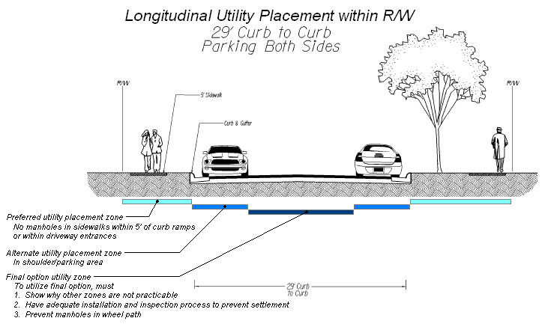

**Design Requirements and Agreements**

**Utilities (continued)**

This sketch shows the preferred location for underground utilities as well as two alternative locations. This example is similar to the sketch on the previous page with the exception that the road is 24 feet wide and parking is allowed on only the left side of the road.

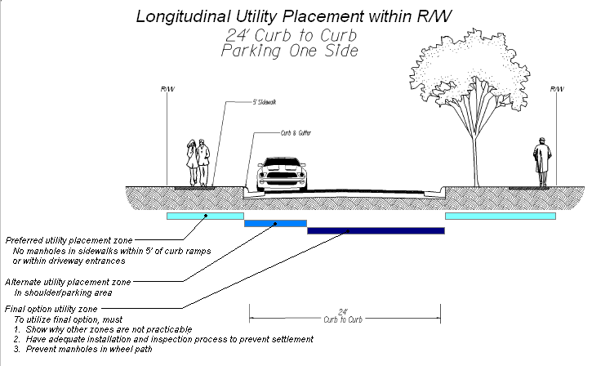

**Design Requirements and Agreements (continued)**

**I. Cul-de-sacs and Turnarounds**

At the end of all cul-de-sacs, an adequate turnaround area shall be constructed to allow for safe and convenient maneuvering by vehicles. Specific cul-de-sac and turnaround designs are illustrated in the agency’s Road Design Manual, Appendix B(1). Alternative turnaround configurations may be approved by the District Administrator’s Designee. When an alternative approach is approved and constructed, additional right-of-way may be required.

If a turnaround or roundabout includes a non-travel area, such area must be included in the dedicated right-of-way unless the agency and the locality are able to reach an agreement for the maintenance of such non-traveled areas.

Stormwater management facilities may be located within the non-traveled area of a cul-de-sac if they meet all of the requirements within the Drainage section (24VAC30-92-120, L) of the [SSAR](http://www.virginiadot.org/projects/resources/SSAR_Final_Registrar_Regulation.pdf) located on page 40 of the regulation.

**J. Curb and Gutter**

There are no requirements in the SSAR for streets to be constructed using curb and gutter. In the event streets are built with curb and gutter, such construction shall be required to meet the standards contained within the [Road Design Manual and the Subdivision Street Design Guide](http://www.virginiadot.org/business/locdes/rdmanual-index.asp).

**K. Private Entrances**

As with curb and gutter, all private entrances shall be required to meet the standards contained within the [Road Design Manual and the Subdivision Street Design Guide.](http://www.virginiadot.org/business/locdes/rdmanual-index.asp)

**L. Roadway Drainage and Low Impact Development Techniques**

VDOT’s primary reference document which details the requirements for roadway drainage is the [VDOT Drainage Manual](http://www.virginiadot.org/business/locdes/hydra-drainage-manual.asp). The 2011 SSAR was revised to include provisions to require that developers comply with the Virginia Stormwater Management Program and if applicable, VDOT’s MS4 Program Plan.

**Design Requirements and Agreements**

**Drainage (continued)**

**Devices within the VDOT Right-of-way**

Stormwater management devices and treatments are generally located outside of the VDOT right-of way. However, low impact development techniques may be placed within the right-of-way if the department and the local governing body have executed an agreement for the maintenance of such facilities. Agreement forms for stormwater management devices located within VDOT right-of-way are located on pages 104 and 107 of the Guidance Document.

The benefits of these devices include reduced quantity of stormwater runoff and improved quality of runoff. These mandatory agreements must include the following language:

1. Acknowledgement that the department has no responsibility or liability due to the presence of the devices or treatments
2. Assures the burden and costs of inspection, maintenance, future improvements to the devices and treatments, or other costs related to the placement of such devices or treatments within the right-of-way are provided from sources other than those administered by the department
3. A statement from a Virginia licensed professional engineer or the manufacturer of the device that certifies the construction of the facility to plans reviewed by the department; and
4. The device, treatment, or concept of the facility is included in the department’s Drainage Manual, the Department of Conservation, or the [Department of Conservation and Recreation’s Best Management Practices (BMP) Clearinghouse website](http://www.dcr.virginia.gov/lr2h.shtml). The BMP website is updated on a continuing basis and will include current information.

Any drainage device located outside of the right-of-way will be designed to prevent the backup of water against the roadbed. If the development activity results in increased runoff to the extent that adjustment of an outfall facility is required, such adjustment shall be at the developer's expense and shall be contained within an appropriate easement.

**Design Requirements and Agreements**

**Drainage (continued)**

**Municipal Separate Storm Sewer System Compliance**

VDOT is required to implement and comply with the Municipal Separate Storm Sewer System (MS4) permit requirements for facilities located on its right-of-way. To comply with these requirements, the local governing body shall provide information regarding all aspects of a proposed development’s stormwater management system that are pertinent to the locality’s or the agency’s MS4 permit. This information shall be submitted to the District Administrator’s Designee as a condition of street acceptance.

**Frequently Asked Questions: Design Requirements**

1. Street widths: Can a developer build a street wider than what is contained within the Subdivision Street Design Guide? Can a local jurisdiction require street widths that exceed VDOT requirements?

* Yes, they may be built wider but VDOT encourages developers to build to the standards and widths included within the Subdivision Street Design Guide, as the width of a street may impact the speed of vehicles on that facility. Studies have found a correlation between increased widths on local streets and higher accident rates and speeds. In addition, studies have found that higher speeds result in increased severity of accidents. Local governments and developers should consider these factors when considering larger local street widths.

1. Stormwater Management Devices: How much detail will VDOT require for stormwater devices to be placed in the right-of-way?

* VDOT will require plan details to ensure that the devise will not present a safety hazard and any “ponded” water will not affect the sub-base. A statement from a Virginia licensed professional engineer or the manufacturer of the device that certifies the construction of the facility to plans reviewed by the department will also be required.

1. Street Widths: What are the ditch sections street widths and when were they changed?

* Ditch widths are provided in Table 2 of the [Subdivision Street Design Guide](http://www.extranet.vdot.state.va.us/locdes/Electronic%20Pubs/2005%20RDM/AppendB(1).pdf). Ditch widths depicted within a typical section contain a note relative to how ditch slopes should be modified to accommodate clear zone requirements when sidewalks are not utilized. Ditch widths did not change in the new 2009 version of the Subdivision Street Design Guide.

**Design Requirements and Agreements**

**Frequently Asked Questions (continued)**

1. Parking signage: When parking is required on one side of the street, how does VDOT want the parking side indicated?

* Parking requirements are the responsibility of the locality. Each locality may have different policies on the placement and types of signs. It would be in the best interest of the developer to verify the requirements of the locality.

1. Street widths and parking: With reduced street widths and on-street parking, will there be adequate emergency access?

* Yes, the typical sections of the Road Design Manual were modified to ensure that at least a fifteen foot lane is free of parked vehicles and available at all times. In addition, design features such as bulb-outs may be used at intersections and at mid-block to help improve emergency access.

1. Parking and garages: Do garages count when considering parking requirements?

* Yes, parking spaces in garages do count when calculating parking requirements.

1. Right of way widths and stormwater management: Can right of way widths be flexible in order to accommodate a stormwater management facility?

* Right of way (including easements) must, at a minimum, be sufficient to accommodate maintenance of any VDOT facility.

1. Speed limits: Some counties have requirements for speed limits for collectors and arterials. The regulations indicate that a speed study will determine the posted speed after construction. If the speed study indicates a higher speed, which one should be posted?

* Requirement is that a speed study be provided to justify speed limit that differs from state statutory limits – the design speed of facility is part of such a study.
* The Commonwealth Transportation Commissioner establishes the speed limit for all highways under the jurisdiction of VDOT in accordance with Section 46.2-878 of the Code of Virginia. All highways under VDOT’s jurisdiction are subject to this requirement.
* In order to establish a speed limit after construction of a roadway, a speed study needs to be conducted to determine the correct speed limit. If the speed study supports a higher (Not in conflict with Section 46.2-870 of the Code of Virginia) or lower speed limit that will be the speed limit that needs to be posted. The design speed is just one of the factors considered when conducting the speed study. On highways under the jurisdiction of VDOT, the Commissioner must approve the speed limit as recommended by the speed study before it can be posted.



**Secondary Street**

**Acceptance Requirements**

**Right-of-Way Requirements and Related Processes**

**10)** **Right-of-Way Requirements and Related Processes** (Page 48 and section 30-92-130 within the SSAR)

Prior to the acceptance of any street network or individual street, VDOT must have a clear and unencumbered right-of-way. In the event that there is an easement which could interfere with this unencumbered use, the street shall be the subject of a quitclaim prior to acceptance. This situation often occurs in conjunction with utilities within VDOT’s right-of-way.

**A. Width of Right-of-Way**

The required width of the VDOT right-of-way is included within the agency’s [Subdivision Street Design Guide](http://www.extranet.vdot.state.va.us/locdes/Electronic%20Pubs/2005%20RDM/AppendB(1).pdf) in the Road Design Manual. The right-of-way shall be broad enough to accommodate all VDOT maintained assets such as pedestrian facilities and safety recovery zones.

**B. Widening of Existing VDOT Roads**

In the event that a VDOT street is to be widened, additional right-of-way should be dedicated in the following manner:

1. If the existing right-of-way is a prescriptive easement, the right-of-way shall be dedicated from the centerline of the road.
2. All additionally required right-of-way shall be dedicated to public use.
3. If the existing right-of-way is titled in the name of the agency or the state, the additional right-of-way will be titled in the same manner.

**C. Spite Strips**

Spite strips are narrow sections of land which restrict the access to adjacent properties. VDOT will not approve or accept streets or rights–of–way that contain spite strips.

**D. Encroachment Within the Right-of-Way**

At the time a developer records a plat, the fee simple interest of the right-of-way is dedicated to public use and the interest is transferred to the local governing body. Any object which is located in the right-of-way and which is a non-VDOT, non-transportation device encroaches on the right-of-way and will be considered unlawful. Exceptions to this policy include posts, signs, walls, or ornamental objects which do not interfere with the roadway and do not conflict with VDOT regulations or the Code of Virginia. Such objects may only remain in the right-of-way if they are approved by VDOT and the owner obtains a land use permit. An exception to the above encroachment involves mailboxes that are constructed with breakaway posts; such objects can be located in the right-of-way without the issuance of a land use permit.



**Secondary Street**

**Acceptance Requirements**

**Surety, Fees and Inspections Required**

**11)** **Surety and Fees** (Page 50 and section 30-92-140 within the SSAR)

It is the responsibility of the developer to guarantee the quality of construction and the performance of the streets that are intended for VDOT acceptance for maintenance. The developer is required to follow all of VDOT’s construction and inspection procedures in order for the newly constructed streets to be accepted into the secondary system. In conjunction with the SSAR, VDOT has developed an Inspections Manual to guide the development community through the inspections and testing processes. This Manual will improve the consistency of inspections through statewide standards. The developer will provide the following:

1. Surety to warranty proper construction of the street,
2. Inspection fee to fund VDOT’s direct costs to inspect the new street for acceptance, and
3. Administrative processing fee to recover the review and acceptance processing costs related to the development.

Sureties will be based upon the date the local governing body requests that the new street(s) be accepted by VDOT for maintenance. The above sureties and fees are determined by the type of inspection completed. The four types of inspections include:

1. VDOT standard inspection
2. Local government administered inspection program
3. Third party inspection
4. VDOT comprehensive construction inspection program equivalent to a third party inspection

**A. Surety**

Only developments which are reviewed using a standard VDOT inspection method, pursuant to 24 VAC 30-92-140, B, 1, will pay the traditional surety. It is the responsibility of the developer to ensure the performance of the street constructed. To warranty the quality of the roadway, the developer will provide a surety to VDOT. The developer is required to supply the agency with the appropriate surety within thirty days of the local governing body’s resolution requesting that VDOT accept the newly constructed street(s). In the event that the developer does not submit proper surety to the agency within the proper time frame, the development’s final construction inspection will be voided and a new inspection shall be required.

**Surety, Fees and Inspections Required**

**Surety (continued)**

Acceptable forms of surety include the following:

1. Performance Bond – Held by VDOT until expiration
2. Cash Deposit – Held and deposited by VDOT but does not accrue interest
3. Certified Check - Held by and deposited by VDOT but does not accrue interest
4. Irrevocable Letter of Credit – Held by VDOT
5. Third Party Escrow Account – Executed by VDOT until expiration. Under no circumstances shall VDOT, the Commonwealth, or any other state agency be named the escrow agent.
6. Other surety mutually acceptable to VDOT and the developer

**Amount Surety**

Surety is only required when the “VDOT standard inspection” is utilized. The surety amount is:

* $3,000 for each tenth of a lane mile, and any portion thereafter.

For example, a two lane road that is 1.08 mile would have a surety of:

* Two lanes x 1.08 miles = 2.16 miles x 10 (tenths of per mile) = 21.6 tenths (rounded up to 22)
* 22 times $3,000 per lane mile = $66,000

The Commonwealth Transportation Board (CTB) has the ability to adjust this amount on an annual basis. This amendment of the surety amount would be based upon changes in the producer price index for street construction materials. The surety amount cannot be greater than $5,000 per tenth of a lane mile.

**Length of Surety for Standard VDOT Inspection**

The surety will guarantee the performance of the street’s construction for a period of one year. This period will begin from the date of the street’s acceptance into the state system.

**Rural Addition, Economic Development, Public Recreation, and Historical Site Streets**

Streets entering VDOT’s secondary system pursuant to the following Code of Virginia sections and related uses, will have the corresponding surety and fees waived:

* Rural Additions - §§33.2-335 and 33.2-336
* Economic Development projects - §33.2-1509
* Public recreation and historical site streets - §33.2-1510

**Surety, Fees and Inspections Required (continued)**

**B. Alternatives to Surety**

Surety will be waived for street acceptance when there is an approved third party inspection, a VDOT comprehensive inspection, or a local government inspection program in place and utilized.

**Third Party Inspections**

Within the SSAR, VDOT created an alternative to traditional agency inspected streets. This new inspection process will provide greater flexibility to the development community. Third party inspections are covered in section 24 VAC 30-92-140, 2, c on page 52 of the SSAR. These inspections are also discussed in VDOT’s Inspections Manual.

In order for a third party to inspect new secondary streets, the following requirements must be met:

1. Developer must contract with a licensed inspection firm not related to or affiliated with the developer or contractor.
2. Inspection procedures, testing methodology, and frequency of inspections are completed in accordance with VDOT Materials Division’s Manual of Instructions and the Virginia Department of Transportation Road and Bridge Specifications.
3. A report must be submitted to VDOT which summarizes the inspections steps completed, certification of the results of inspection, and confirmation that the streets were built to the approved specifications and pavement design, signed, and stamped by a Virginia licensed professional engineer.

When the third party inspection alternative is utilized, the applicable surety shall be waived and the street inspection fee is reduced by 75%.

**Localities with Street Construction Inspection Programs**

If a locality has a comprehensive street construction inspection program that is approved by VDOT, no surety is required. This program is discussed in section 24 VAC 30-92-140, 2, a on page 51 of the SSAR.

Following the approval of such an inspection program by VDOT, the agency will certify localities as able to inspect newly constructed streets within their boundaries. In these instances, the surety shall be waived if the local governing body certifies that the new street or addition has been constructed consistent with the approved plans and specifications. The surety shall be waived and the street inspection fee is reduced by 75% when this inspection method is utilized.

**Surety, Fees and Inspections Required**

**Alternatives to Surety (continued)**

**VDOT Comprehensive Construction Inspection Program**

At the request of the developer, VDOT may perform the construction inspection equivalent to that required for third party inspection of any street or streets proposed to be added to the secondary system of state highways. VDOT comprehensive inspections are contingent upon the availability of appropriate VDOT staff. This type of inspection is discussed in section 24 VAC 30-92-140, 2, b on page 51 of the SSAR. The following shall apply when this inspection method is utilized:

* The developer will cover all costs incurred by VDOT
* The surety shall be waived

1. **Administrative Cost Recovery Fee**

The purpose of the Administrative Cost Recovery Fee is to recover a portion of VDOT’s direct costs related with the review of plats and plans. It also will cover the administrative processing of the acceptance of new streets.

The fee will be required from the developer when the streets are accepted or when the county requests VDOT acceptance. The following equation will be used to calculate the cost recovery fee:

* Base rate of $500 per addition regardless of street length
* Plus $250 per tenth of a centerline mile or any portion thereafter

**Alternatives to Administrative Cost Recovery Fee**

VDOT administers three alternatives to its Administrative Cost Recovery Fee. These alternatives are discussed in section 24 VAC 30-92-140, C, 2 on page 53 of the SSAR. As an alternative to the Administrative Cost Recovery Fee, VDOT can use one of the following methods to recover its direct administrative costs:

1. The developer may request that VDOT establish an account for the purpose of tracking the related administrative costs. The developer will be billed no more frequently every 30 days.
2. For large, complex, and multi-use developments, VDOT may require that an account be established for the purpose of tracking the administrative costs and bill the developer not more than every 30 days. VDOT staff will determine which developments will qualify for this type of billing. The cost recovery fee assessed under this section shall not be greater than two times the agency administrative cost recovery fee structure. Therefore, this alternative rate will not be greater than a base rate of $1,000 per addition and $500 per tenth of a centerline mile.
3. For streets not intended for maintenance by VDOT, the agency may establish an account for the purpose of tracking these costs and bill the developer not more often than every 30 days.

**Surety, Fees and Inspections Required (continued)**

**D. Street Inspection Fee**

In order to recover a portion of VDOT’s direct costs associated with the inspection of new streets, an inspection fee shall be paid by the developer at the time the streets are accepted by the agency. Street inspection fees are discussed within section 24 VAC 30-92-140, D on page 53 of the SSAR. This inspection fee shall be computed as follows:

* Base rate of $250 per addition, regardless of street length
* Plus $125 per tenth of a centerline mile or portion thereafter

**Third Party Inspection and County Administered Inspection Programs**

The Street Inspection Fee shall be reduced by 75% if either a third party inspection process or a county administered inspection program is used.

**Streets Not Intended for VDOT Maintenance**

If requested to provide inspection services for subdivision streets that are not intended for maintenance by the department, VDOT may establish an account for the purpose of tracking these costs and bill the developer not more often than every 30 days.

**Surety, Fees and Inspections Required (continued)**

**E. Additional Bond Required by VDOT**

During the 2010 session, the General Assembly passed and the Governor approved House Bill 197, which had an effective date of July 1, 2010. This addition to the Code of Virginia §33.2-334 states the following:

*Furthermore, nothing in this section or in any regulation, policy, or practice adopted pursuant to this section shall prevent the acceptance of any street or segment of a street within a network addition that meets one or more of the public service requirements addressed in the regulations provided that the**network addition satisfies all other requirements adopted pursuant to this section. In cases where a**majority of the lots along the street or street segment remain undeveloped and construction traffic is**expected to utilize that street or street segment after acceptance, the bonding requirement for such street**or street segment may be required by the Department to be extended for up to one year beyond that required in the secondary street acceptance requirements.*

The main impact of the above legislation is that VDOT has the ability to require a one year surety (for streets to be accepted under an inspection option that normally does not require a surety) or to require a two year surety (for streets to be accepted under an inspection option that normally requires a one year warranty) for street segments which:

* Meet the public service minimum requirements, but
* Are part of a network addition whose other streets do not provide minimum public service AND
* A majority of lots on the subject street remain undeveloped. Under these circumstances, “undeveloped” means that a locally granted Certificate of Occupancy has not yet been approved for the lot and related land use.
* Under these circumstances, only the subject street segment is accepted into the system, while the remainder of the network addition is not accepted at this time.

When this additional surety is required, it will be in the amount of $3,000 for each tenth of a lane mile and any portion thereafter. The purpose of the legislation is to allow VDOT to accept roads into the system in spite of the remainder of the network addition not serving the required traffic generators while protecting VDOT from the extra costs such roads may impose as they experience significant land development construction traffic.

The District Administrator’s Designee will determine if such a surety will be required for streets that do not meet the public service requirement currently, but can be expected to in the future. At the time of street acceptance, the developer will provide the Designee with supporting documentation which verifies the number of lots on the street and how many of the lots are developed. The designee will then determine if such a surety is warranted. This surety can be charged for all inspection types.

**Surety, Fees and Inspections Required (continued)**

**F. Inspection and Fees Flowcharts**

The following flowcharts display the four major types of street inspections and related fees. Theses inspections include:

1. VDOT standard inspection
2. Third Party inspection
3. Local government administered inspection program
4. VDOT comprehensive construction inspection program

**VDOT Standard Inspection**

This type of inspection is included in section 24 VAC 30-92-140, B, 1 of the SSAR and is included on page 50 of the regulation.



**Surety, Fees and Inspections Required**

**Inspection and Fees Flowcharts (continued)**

**Comprehensive County Construction Inspection Program and Third Party Inspection Process**

These two types of inspections can be found at section 24 VAC 30-92-140, B, 2, subsections “a” and “c.” This is listed on pages 51 and 52 within the SSAR regulation.



**Surety, Fees and Inspections Required**

**Inspection and Fees Flowcharts (continued)**

**VDOT Comprehensive Construction Inspection Program**

This is the VDOT administered program which is equivalent to a third party inspection. This type of inspection is discussed in section 24 VAC 30-92-140, B, 2, “b” on page 51 of the SSAR.





**Secondary Street**

**Acceptance Requirements**

Appendices

### SECONDARY STREET ACCEPTANCE REQUIREMENTS

### EXCEPTION, WAIVER, MODIFICATION REQUEST FORM

|  |  |  |
| --- | --- | --- |
| **Submitted by:** | | **Date:** |
| **Email Address:** | | **Phone:** |
| **Address:** | | |
| **Development or Subdivision Name:** | | |
| **County:** | **Connecting Route # :**      **Name:** | |
| **Description of Proposed Project:** | | |

**FOR VDOT USE ONLY**

Date received by VDOT**:**       Initial review conducted by**:**

District Administrator’s designee**:**       Is request required to be determined by D.A.? **:**

Deadline to finalize request decision**:**       Date developer & locality notified of decision**:**

**NOTEs:**

(i) Attach additional information as necessary describing the reasons for the exception, waiver, or modification request.

(ii) Use the LD-440 Design Exception or the LD-448 Design Waiver forms for design related standards (e.g. design speed). See [IIM-LD-227](http://www.extranet.vdot.state.va.us/locdes/electronic%20pubs/iim/IIM227.pdf).5 for additional instructions.

**Type of Exception, WAIVER OR MODIFICATION**

1. **Stub out connection to an adjacent, existing VDOT maintained stub out** (Section 60, C, 1 in SSAR of regulation)

**Name, route number, and location of existing stub out:**

|  |
| --- |
|  |

**Reason for request:**

Specify reason:

Attached documentation supporting reason for request.

SSAR Exception, Waiver, Modification Request Form (continued)

1. **Multiple Connections in Multiple Directions** (Section 60, C, 2 of regulation)

**Number of connections and related directions being proposed:**

**Reason for request:**

**Why multiple connections in multiple directions can NOT be met.**

|  |
| --- |
|  |

Specify reason:

Attached documentation supporting reason for request.

1. **Additional Connections Standard** (Section 60, C, 3 of regulation)

**Number of connections and related directions being proposed:**

**Reason for request:**

**Why the additional connections standard can NOT be met.**

|  |
| --- |
|  |

Specify reason:

Attached documentation supporting reason for request.

1. **Pedestrian Accommodation Requirements** (Section 120, I of regulation)

**SSAR pedestrian accommodations required for this development:**

**Describe pedestrian accommodations being proposed for development:**

**Reason for request:**

A**. Why can the required pedestrian accommodations NOT be constructed.**

|  |
| --- |
|  |

Specify reason:

Attached documentation supporting reason for request.

B**. Is developer proposing to build equivalent pedestrian accommodations:**

|  |
| --- |
|  |

**If “yes,” explain how the proposal is equivalent or better than the SSAR required facilities:**

Attached documentation supporting reason for request, including plans.

SSAR Exception, Waiver, Modification Request Form (continued)

1. **Public Service Requirement** (Section 60, B of regulation)

**For which Public Service criteria does the developer seek the exception:**

**Reason for request:**

**Why is the Public Service exception being requested?**

|  |
| --- |
|  |

Specify reason:

**How does facility provide Public Service equivalent to the SSAR requirement?**

|  |
| --- |
|  |

Provide specifics:

1. **Other SSAR Exception, Waiver or Modification Request (insert information for each individual request being made which is not addressed in items #1 through #5 above)**

**Exception, waiver, or modification the developer is requesting:**

**Related section of the SSAR regulation:**

**Reason for request:**

**Why is this request being made?:**

|  |
| --- |
|  |

Specify reason:

Attached documentation supporting reason for request.

SSAR Exception, Waiver, Modification Request Form (continued)

|  |  |
| --- | --- |
| **Request Recommendation: Approve**  **Deny** | **Date:** |
| **Person completing recommendation:** | |
| **Reasons for recommendation (required):** | |

|  |  |
| --- | --- |
| **Request Action:** **Approved**  **Denied** | **Date:** |
| **Action taken by District Administrator or Designee (name):** | |
| **Reasons for action (required)****:** | |

**Stub Out Street**

**Sign Specifications**

**Normal Stub Street:**

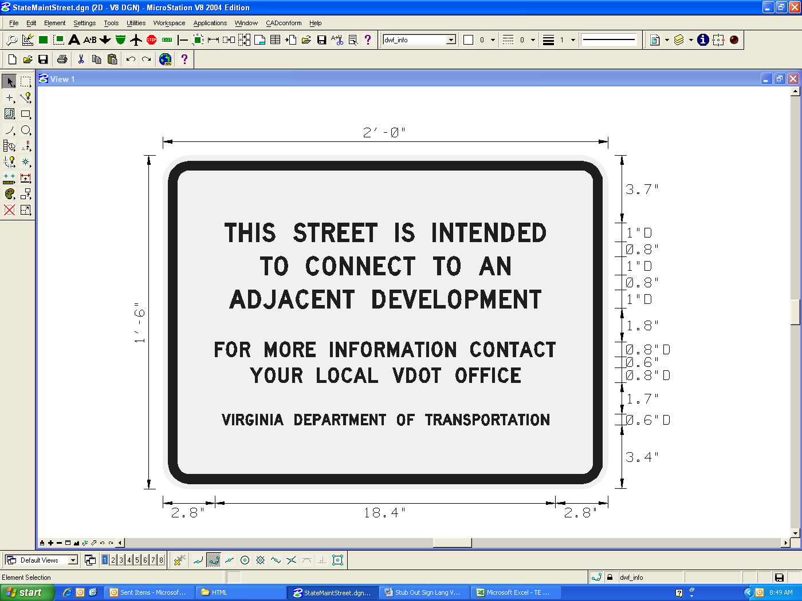

Border Radius: 1.125”

Border Thickness: 0.5”

**Stub Street Adjacent to Infill Development:**

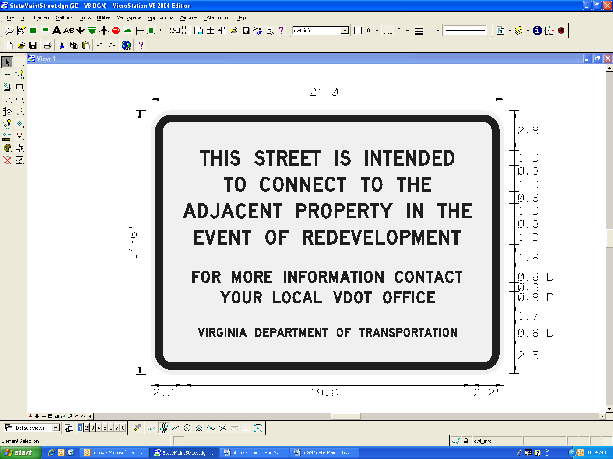

Border Radius: 1.125”

Border Thickness: 0.5”

Comprehensive Agreement for Pedestrian Facilities Outside of VDOT Right-of-way - Dated: ________

County of ________________________

**PEDESTRIAN FACILITIES LOCATED OUTSIDE OF SECONDARY HIGHWAY SYSTEM RIGHT-OF-WAY**

**AGREEMENT FOR**

**COUNTY of ______________________**

THIS AGREEMENT, is made this ______ day of _________________________, ______ between the Board of Supervisors of ______________ (the "County"), party of the first part, and the Commonwealth of Virginia, Department of Transportation ("VDOT"), party of the second part, for the purpose of satisfying 24VAC30-92-120.I of the Secondary Street Acceptance Requirements for the addition of secondary streets made after this date throughout the County.

RECITALS

1. WHEREAS, the County may approve the creation of certain developments which include the construction of new streets intended to be taken into the secondary system of state highways.
2. WHEREAS, included in the design and construction of said streets, VDOT may require the construction of certain pedestrian accommodations.
3. WHEREAS, VDOT will maintain those compliant pedestrian accommodations which are located within highway right-of-way of streets accepted into the secondary system, but VDOT will not be responsible for the design, construction, maintenance, and improvement of pedestrian facilities located outside of highway right-of-way.
4. WHEREAS, a prerequisite for accepting any street into the secondary system of state highways is the provision that developments whose streets are intended to be accepted into the secondary system satisfy the public benefit requirements contained within the Secondary Street Acceptance Requirements which includes pedestrian facilities.
5. WHEREAS, pursuant to 24 VAC 30-92-120.I of the Secondary Street Acceptance Requirements, pedestrian facilities necessary to satisfy the public benefit requirements may be located outside of the Virginia Department of Transportation’s right-of-way and documents regarding the arrangements providing for the maintenance of such pedestrian facilities shall be provided to VDOT prior to the transfer of jurisdiction over the streets to VDOT.
6. WHEREAS, the pedestrian accommodations must be contained within a perpetual public easement that is accessible to all.

NOW, THEREFORE, in consideration of the premises, the mutual covenants stated herein, and other good and valuable consideration the receipt and sufficiency of which is acknowledged by all parties hereto, the parties hereto agree as follows:

1. The County acknowledges that VDOT has no responsibility or liability associated with pedestrian facilities located outside of highway right-of-way.
2. The County assures the burden and all costs of inspection, construction, maintenance, and future improvements to these pedestrian facilities, or other costs related to the placement of the facilities outside of highway right-of-way and such funds shall be provided from sources other than those administered by VDOT.
3. The County shall make formal arrangements to insure that pedestrian facilities located outside of secondary highway right-of-way are sufficiently maintained and such documentation of this arrangement will be supplied to VDOT prior to street acceptance.
4. The County shall not request that VDOT accept a street for maintenance as part of the secondary system of state highways until the developer or County has constructed the required pedestrian facility and applied for an in-place connection permit for the area in which the pedestrian facilities intersect highway right-of-way.
5. VDOT agrees to issue an in-place connection permit for the pedestrian facilities in conjunction with the acceptance of the street into the secondary system of state highways if the facilities and the new street meet all appropriate requirements contained in the Secondary Street Acceptance Requirements.
6. The parties expressly do not intend by execution of this Agreement to create in the public, or any member thereof, any rights as a third party beneficiary, or to authorize anyone not a party hereto to maintain a suit for any damages pursuant to the terms or provisions of this Agreement. In addition the parties understand and agree that this Agreement is not to be construed as an indemnification against third party claims.
7. The parties hereto agree that the provisions of this Agreement may be invoked by reference in any resolution of the County requesting any future addition to the secondary system of state highways.

Witness the following signatures and seals:

|  |  |  |  |  |
| --- | --- | --- | --- | --- |
| Approved as to Form |  | **Board of Supervisors of** | | |
|  |  |  | |  |
|  |  | By: |  | |
| County Attorney |  | (Name & Title) |  | |
|  |  |  |  | |
|  |  | **COMMONWEALTH OF VIRGINIA DEPARTMENT OF TRANSPORTATION** | | |
|  |  |  |  | |
|  |  | By: |  | |
|  |  |  | Commonwealth Transportation Commissioner | |

COMMONWEALTH OF VIRGINIA, CITY/COUNTY OF __________________________________, to wit:

(Name) __________________________________________________, acknowledged the foregoing instrument before me this ______ day of ________________________, _______.

NOTARY PUBLIC Notary registration number

My commission expires: ______________________

COMMONWEALTH OF VIRGINIA, CITY OF RICHMOND, to wit:

(Name) __________________________________________________, “Commonwealth Transportation Commissioner”, party of the second part, acknowledged the foregoing instrument before me this ________ day of ________________________, _______.

NOTARY PUBLIC Notary registration number

My commission expires: ______________________

Development Specific Agreement for Pedestrian Facilities Outside of VDOT Right-of-way - Dated: ________

Development ________________________

**PEDESTRIAN FACILITIES LOCATED OUTSIDE OF SECONDARY HIGHWAY SYSTEM RIGHT-OF-WAY**

**AGREEMENT FOR**

________________________________

THIS AGREEMENT, is made this ______ day of _________________________, ______ between the Board of Supervisors of ______________ (the "County"), party of the first part, and the Commonwealth of Virginia, Department of Transportation ("VDOT"), party of the second part, for the purpose of satisfying 24VAC30-92-120.I of the Secondary Street Acceptance Requirements for the addition of secondary streets within the development commonly known as ___________________.

RECITALS

R-1 WHEREAS, the County approved the creation of a development known as _____________ which includes the construction of new street(s) intended to be taken into the secondary system of state highways.

R-2 WHEREAS, included in the design and construction of said street(s), VDOT may require the construction of certain pedestrian accommodations.

R-3 WHEREAS, VDOT will maintain those compliant pedestrian accommodations which are located within highway right-of-way of streets accepted into the secondary system, but VDOT will not be responsible for the design, construction, maintenance, and improvement of pedestrian facilities located outside of highway right-of-way.

R-4 WHEREAS, a prerequisite for accepting any street into the secondary system of state highways is the provision that developments whose streets are intended to be accepted into the secondary system satisfy the public benefit requirements contained within the Secondary Street Acceptance Requirements, which includes pedestrian facilities.

R-5 WHEREAS, pursuant to 24 VAC 30-92-120.I of the Secondary Street Acceptance Requirements, pedestrian facilities necessary to satisfy the public benefit requirements may be located outside of the Virginia Department of Transportation’s right-of-way and documents regarding the arrangements providing for the maintenance of such pedestrian facilities shall be provided to VDOT prior to the transfer of jurisdiction over the street to VDOT.

R-6 WHEREAS, the pedestrian accommodations must be contained within a perpetual public easement that is accessible to all.

NOW, THEREFORE, in consideration of the premises, the mutual covenants stated herein, and other good and valuable consideration the receipt and sufficiency of which is acknowledged by all parties hereto, the parties hereto agree as follows:

1. The County acknowledges that VDOT has no responsibility or liability associated with pedestrian facilities located outside of the highway right-of-way.
2. The County assures the burden and all costs of inspection, construction, maintenance, and future improvements to these pedestrian facilities, or other costs related to the placement of the facilities outside of highway right-of-way and such funds shall be provided from sources other than those administered by VDOT.
3. The County shall make formal arrangements to insure that pedestrian facilities located outside of secondary highway right-of-way are sufficiently maintained and such documentation of this arrangement will be supplied to VDOT prior to street acceptance.
4. The County shall not request that VDOT accept a street for maintenance as part of the secondary system of state highways until the developer or County has constructed the required pedestrian facility and applied for an in-place connection permit for the area in which the pedestrian facilities intersect highway right-of-way.
5. VDOT agrees to issue an in-place connection permit for the pedestrian facilities in conjunction with the acceptance of the street into the secondary system of state highways if the facilities and the new street meet all appropriate requirements contained in the Secondary Street Acceptance Requirements.
6. The parties expressly do not intend by execution of this Agreement to create in the public, or any member thereof, any rights as a third party beneficiary, or to authorize anyone not a party hereto to maintain a suit for any damages pursuant to the terms or provisions of this Agreement. In addition the parties understand and agree that this Agreement is not to be construed as an indemnification against third party claims.

Witness the following signatures and seals:

|  |  |  |  |  |
| --- | --- | --- | --- | --- |
| Approved as to Form |  | **Board of Supervisors of** | | |
|  |  |  | |  |
|  |  | By: |  | |
| County Attorney |  | (Name & Title) |  | |
|  |  |  |  | |
|  |  | **COMMONWEALTH OF VIRGINIA DEPARTMENT OF TRANSPORTATION** | | |
|  |  |  |  | |
|  |  | By: |  | |
|  |  |  | Commonwealth Transportation Commissioner | |

COMMONWEALTH OF VIRGINIA, CITY/COUNTY OF __________________________________, to wit:

(Name) __________________________________________________, acknowledged the foregoing instrument before me this ______ day of ________________________, _______.

NOTARY PUBLIC Notary registration number

My commission expires: ______________________

COMMONWEALTH OF VIRGINIA, CITY OF RICHMOND, to wit:

(Name) __________________________________________________, “Commonwealth Transportation Commissioner”, party of the second part, acknowledged the foregoing instrument before me this ________ day of ________________________, _______.

NOTARY PUBLIC Notary registration number

My commission expires: ______________________

Comprehensive Stormwater Device Agreement Dated: ________

County of ________________________

**STORMWATER DEVICE LOCATED WITHIN VDOT RIGHT-OF-WAY**

**AGREEMENT FOR**

**COUNTY of ___________________**

THIS AGREEMENT, is made this ______ day of _________________________, ______ between the Board of Supervisors of       (the "County"), party of the first part, and the Commonwealth of Virginia, Department of Transportation ("VDOT"), party of the second part, for the purpose of satisfying 24VAC30-92-120. L of the Secondary Street Acceptance Requirements for the addition of secondary streets made after this date throughout the County.

RECITALS

R-1 WHEREAS, the County may approve the creation of certain developments which include the construction of new streets intended to be taken into the secondary system of state highways.

R-2 WHEREAS, included in the design and construction of said streets may be certain devices and easements for the purpose of constructing, operating and maintaining present or future stormwater drainage facilities for removing water from said streets.

R-3 WHEREAS, a prerequisite for accepting any street into the secondary system of state highways, is the provision of an adequate and acceptable method and related devices for transporting stormwater runoff from said street to a natural water course.

R-4 WHEREAS, pursuant to 24 VAC 30-92-120.L.2 of the Secondary Street Acceptance Requirements, when stormwater devices are approved by the locality to be located in the right-of-way of streets intended for acceptance into the secondary system and incorporated into stormwater drainage facilities, the governing body of the locality shall acknowledge that VDOT is not responsible for the operation, maintenance, or liability of the stormwater management facility or facilities associated with the development and that VDOT will not accept said streets until such agreement has been officially adopted by the local governing body.

NOW, THEREFORE, in consideration of the premises, the mutual covenants stated herein, and other good and valuable consideration the receipt and sufficiency of which is acknowledged by all parties hereto, the parties agree as follows:

1. The County acknowledges that VDOT has no responsibility or liability due to the presence in the secondary highway right-of-way of the stormwater and drainage devices or treatments, or both.
2. The County will not seek indemnification or contribution from VDOT to correct damages arising from improper maintenance or construction of these stormwater devices and facilities.
3. The County assures the burden and all costs of inspection, maintenance, future improvements to the devices and treatments, or other costs related to the placement of devices or treatments within highway right-of-way are and shall be provided from sources other than those administered by VDOT.
4. The County shall not request VDOT accept a street for maintenance as part of the secondary system of state highways until a professional engineer licensed by the Commonwealth or the manufacturer of the stormwater device as required by VDOT, certifies the construction of any stormwater drainage facility placed within the right of way of such street to plans reviewed by VDOT.
5. The County shall require that a detailed concept plan for the device and facility has been provided to VDOT which complies with the department’s Drainage Manual and the Department of Conservation and Recreation's Stormwater Handbook.
6. All related adjustments and improvements to the stormwater devices and facilities shall not be at VDOT’s expense and shall be contained within an appropriate easement.
7. The County shall not request VDOT accept a street for maintenance as part of the secondary system of state highways until the developer or County has applied for an in-place permit for the stormwater facilities and has furnished all required information and data to the agency concerning the pertinent Municipal Separate Storm Sewer System permit.
8. The parties expressly do not intend by execution of this Agreement to create in the public, or any member thereof, any rights as a third party beneficiary, or to authorize anyone not a party hereto to maintain a suit for any damages pursuant to the terms or provisions of this Agreement. In addition the parties understand and agree that this Agreement is not to be construed as an indemnification against third party claims.
9. VDOT agrees to issue an in-place permit for the stormwater facilities in conjunction with the acceptance of the street into the secondary system of state highways if the facility and the new street meet the appropriate requirements contained in the Secondary Street Acceptance Requirements.
10. The parties hereto agree that the provisions of this Agreement may be invoked by reference in any resolution of the County requesting any future addition to the secondary system of state highways.

Witness the following signatures and seals:

|  |  |  |  |  |
| --- | --- | --- | --- | --- |
| Approved as to Form |  | **Board of Supervisors of** | | |
|  |  |  | |  |
|  |  | By: |  | |
| County Attorney |  | (Name & Title) |  | |
|  |  |  |  | |
|  |  | **COMMONWEALTH OF VIRGINIA DEPARTMENT OF TRANSPORTATION** | | |
|  |  |  |  | |
|  |  | By: |  | |
|  |  |  | Commonwealth Transportation Commissioner | |

COMMONWEALTH OF VIRGINIA, CITY/COUNTY OF __________________________________, to wit:

(Name) __________________________________________________, acknowledged the foregoing instrument before me this ______ day of ________________________, _______.

NOTARY PUBLIC Notary registration number

My commission expires: ______________________

COMMONWEALTH OF VIRGINIA, CITY OF RICHMOND, to wit:

(Name) __________________________________________________, “Commonwealth Transportation Commissioner”, party of the second part, acknowledged the foregoing instrument before me this ________ day of ________________________, _______.

NOTARY PUBLIC Notary registration number

My commission expires: ______________________

Stormwater Device Agreement Dated: ________

Development ________________________

**STORMWATER DEVICE LOCATED WITHIN VDOT RIGHT-OF-WAY**

**AGREEMENT FOR**

**__________________________ DEVELOPMENT**

THIS AGREEMENT, is made this ______ day of _________________________, ______ between the Board of Supervisors of       (the "County"), party of the first part, and the Commonwealth of Virginia, Department of Transportation ("VDOT"), party of the second part, for the purpose of satisfying 24VAC30-92-120.L of the Secondary Street Acceptance Requirements for the addition of secondary streets within the development commonly known as _____________________.

RECITALS

R-1 WHEREAS, the County approved the creation of the development known as ____________which includes the construction of new streets intended to be taken into the secondary system of state highways.

R-2 WHEREAS, included in said development is the design and construction of streets which include certain stormwater devices and facilities for removing water from said streets.

R-3 WHEREAS, a prerequisite for accepting any street into the secondary system of state highways is the provision of an adequate and acceptable method and related devices for transporting stormwater runoff from said streets to a natural water course.

R-4 WHEREAS, pursuant to 24 VAC 30-92-120.L.2 of the Secondary Street Acceptance Requirements, when stormwater devices are approved by the locality to be located in the right-of-way of streets intended for acceptance into the secondary system and incorporated into stormwater drainage facilities, the governing body of the locality shall acknowledge that the VDOT is not responsible for the operation, maintenance, or liability of the stormwater management facility or facilities associated with the development and that VDOT will not accept said streets until such agreement has been officially adopted by the local governing body.

NOW, THEREFORE, in consideration of the premises, the mutual covenants stated herein, and other good and valuable consideration the receipt and sufficiency of which is acknowledged by all parties hereto, the parties agree as follows:

1. The County acknowledges that VDOT has no responsibility or liability due to the presence in the secondary highway right-of-way of the stormwater and drainage devices or treatments, or both.
2. The County will not seek indemnification or contribution from VDOT to correct damages arising from improper maintenance or construction of these stormwater devices and facilities.
3. The County assures the burden and all costs of inspection, maintenance, future improvements to the devices and treatments, or other costs related to the placement of devices or treatments within highway right-of-way are and shall be provided from sources other than those administered by VDOT.
4. The County shall require that a detailed concept plan for the device and facility has been provided to VDOT which complies with the department’s Drainage Manual and the Department of Conservation and Recreation's Stormwater Handbook.
5. The County shall not request VDOT accept a street for maintenance as part of the secondary system of state highways until a professional engineer licensed by the Commonwealth or the manufacturer of the stormwater device as required by VDOT, certifies the construction of any stormwater drainage facility placed within the right of way of such street to plans reviewed by VDOT.
6. All related adjustments and improvements to the stormwater devices and facilities shall not be at VDOT’s expense and, for that portion of such devices and facilities that exist outside of highway right-of-way, shall be contained within an appropriate easement.
7. The County shall not request VDOT accept a street for maintenance as part of the secondary system of state highways until the developer or County has applied for an in-place permit for the stormwater facilities and has furnished all required information and data to the agency concerning the pertinent Municipal Separate Storm Sewer System permit.
8. VDOT agrees to issue an in-place permit for the stormwater facilities in conjunction with the acceptance of the street into the secondary system of state highways if the facility and the new street meet the appropriate requirements contained in the Secondary Street Acceptance Requirements.
9. The parties expressly do not intend by execution of this Agreement to create in the public, or any member thereof, any rights as a third party beneficiary, or to authorize anyone not a party hereto to maintain a suit for any damages pursuant to the terms or provisions of this Agreement. In addition the parties understand and agree that this Agreement is not to be construed as an indemnification against third party claims.

Witness the following signatures and seals:

|  |  |  |  |  |
| --- | --- | --- | --- | --- |
| Approved as to Form |  | **Board of Supervisors of** | | |
|  |  |  | |  |
|  |  | By: |  | |
| County Attorney |  | (Name & Title) |  | |
|  |  |  |  | |
|  |  | **COMMONWEALTH OF VIRGINIA DEPARTMENT OF TRANSPORTATION** | | |
|  |  |  |  | |
|  |  | By: |  | |
|  |  |  | Commonwealth Transportation Commissioner | |

COMMONWEALTH OF VIRGINIA, CITY/COUNTY OF __________________________________, to wit:

(Name) __________________________________________________, acknowledged the foregoing instrument before me this ______ day of ________________________, _______.

NOTARY PUBLIC Notary registration number

My commission expires: ______________________

COMMONWEALTH OF VIRGINIA, CITY OF RICHMOND, to wit:

(Name) __________________________________________________, “Commonwealth Transportation Commissioner”, party of the second part, acknowledged the foregoing instrument before me this ________ day of ________________________, _______.

NOTARY PUBLIC Notary registration number

My commission expires: ______________________

**Technical Resources List**

In addition to the documents incorporated by reference within the SSAR regulation, the following technical resource publications may also be helpful.

**AASHTO Bookstore:**

<https://bookstore.transportation.org/category_item.aspx?id=DS>

* AASHTO A Policy on the Geometric Design of Highways and Streets
* AASHTO Roadside Design Guide
* AASHTO Guide for the Planning, Design, and Operation of Pedestrian Facilities
* AASHTO Guide for the Development of Bicycle Facilities

**ACCESS BOARD:**

**Americans with Disabilities Act**

* Revised Draft Guidelines for Accessible Public Rights-of-Way

<http://www.access-board.gov/prowac/draft.htm>

**Federal Highway Administration (FHWA):**

* Manual on Uniform Traffic Control Devices

<http://mutcd.fhwa.dot.gov/>

* FHWA Roundabouts: A Informational Guide

<http://www.tfhrc.gov/safety/00068.htm>

**Institute of Transportation Engineers (ITE) Bookstore:**

<http://www.ite.org/emodules/scriptcontent/Orders/index.cfm>

* ITE Trip Generation Manual
* Trip Generation Handbook – an ITE Proposed Recommended Practice

**Transportation Research Board (TRB):**

<http://gulliver.trb.org/Main/Blurbs/Highway_Capacity_Manual_2000_152169.aspx>

* TRB Highway Capacity Manual

**Technical Resources List (continued)**

**VDOT Manuals and Guides:**

<http://www.virginiadot.org/business/manuals-default.asp>

* VDOT Road Design Manual

<http://www.virginiadot.org/business/locdes/rdmanual-index.asp>

* Instructional & Information Memoranda

<http://www.extranet.vdot.state.va.us/locdes/electronic%20pubs/iim/iim-table-of-contents.pdf>

* VDOT’s Traffic Calming Guide for Local Residential Streets

<http://www.virginiadot.org/business/resources/TrafficCalmingGuideOct2002.pdf>

* VDOT Drainage Manual

<http://www.virginiadot.org/business/locdes/hydra-drainage-manual.asp>

* Chapter 527 Traffic Impact Analysis Regulations

<http://www.virginiadot.org/projects/landuse.asp>

**Virginia Department of Conservation and Recreation (DCR):**

* DCR Erosion and Sediment Control Manual (Also see VDOT Drainage Manual and Instructional & Information Memoranda mentioned above)

<http://www.dcr.virginia.gov/soil_and_water/stormwat.shtml>