VIRTUAL DESIGN PUBLIC HEARING
Route 15 (Farmville Highway)
Charlotte County
Thursday, November 12, 2020, 4-6 p.m.
Alternate date: Thursday, November 19

www.VirginiaDOT.org
Lynchburginfo@VDOT.Virginia.gov

All comments submitted will become a part of the meeting transcript and will be made available to the public.

Name (optional):

Address:

- How will the construction of this road improvement along Route 15/360 (Farmville Highway) affect your daily travel?

- Has property access been properly addressed? Yes _____ No _____ If no, please provide additional information.

- Please provide us with any additional information you feel will assist in the completion of this project.

- Did you find the video and graphics provided useful in understanding the project? Yes _____ No _____ If no, please provide suggestions for improvement.

- Do you support this project? Yes _____ No _____

- How did you hear about this meeting? Newspaper _____ Direct Mail _____ VDOT Roadway signs _____

Other ________________________________________

Please submit this comment sheet online or mail your comments
within 10 days (November 22, 2020) to the addressee on the reverse side.

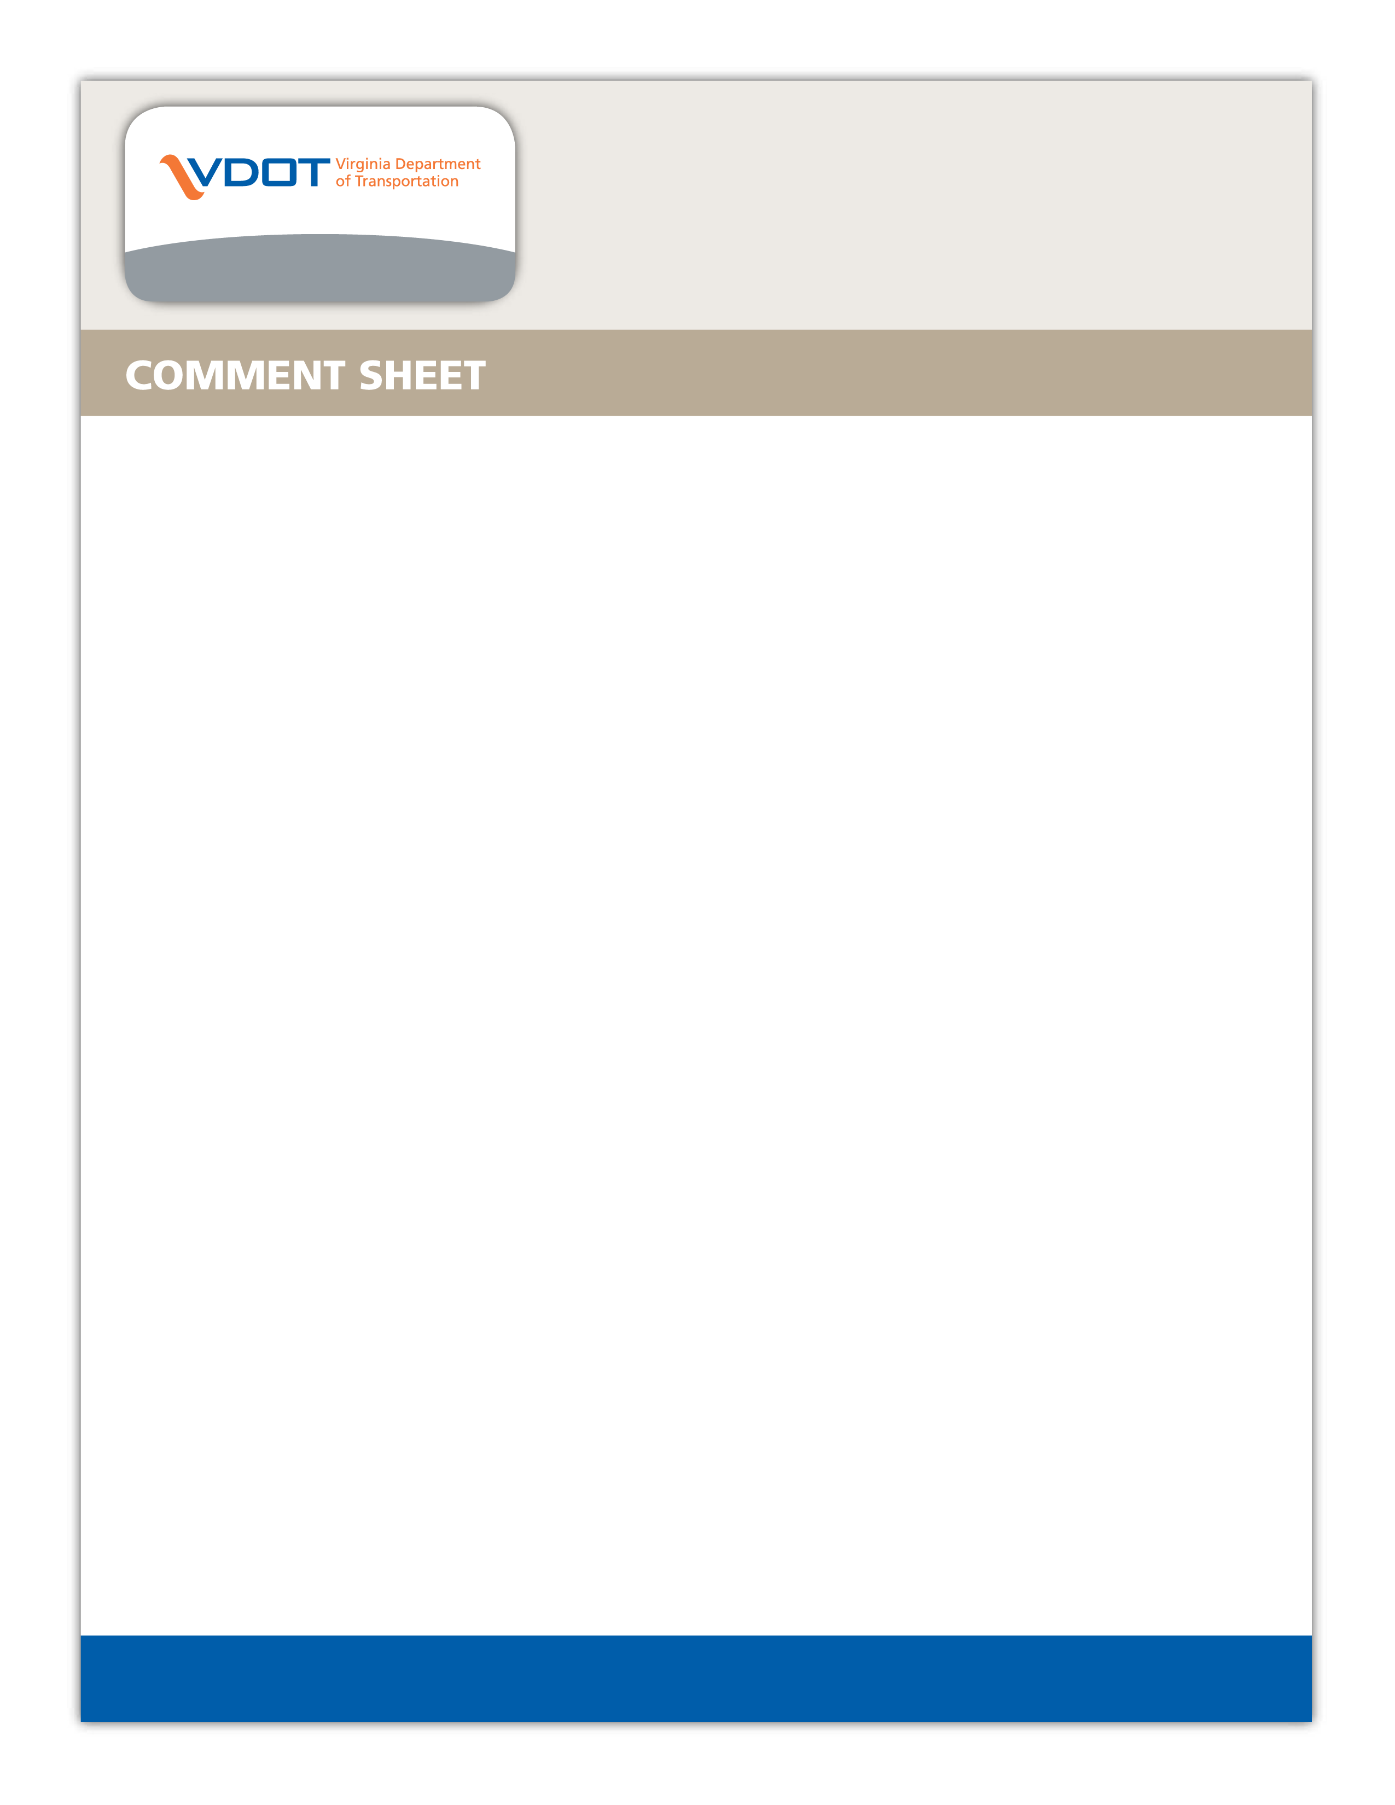

Virginia Department of Transportation
Anthony Revelle, P.E., Project Manager
VDOT Lynchburg District Complex
4219 Campbell Avenue
Lynchburg, VA 24501

Virginia Department Of Transportation
Jeff A. Echols, P.e.
Salem Residency Office
P.o. Box 3071
Salem, Virginia 24153

