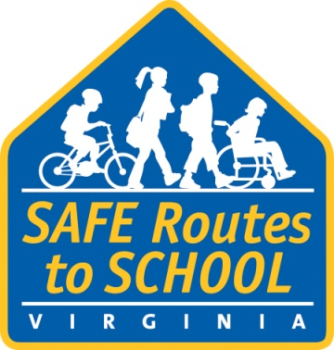**2014-2015 Safe Routes to School**

**Announcements**

**How to use:** Use these announcements to make both students and parents aware of upcoming Safe Routes events. Scripts for two types of announcements are included: one for students in the classroom (or during school assemblies) and one for parents during at-school events. The scripts are Word documents and can be used or modified as needed.

**For students:**

Our school is asking all students to walk and bike to school on **[day], [date],** as part of **[Safe Routes Event, e.g. International Walk to School Day]**.

We’re sending home a backpack flyer about the event to give to your parents today. This will give them more information about the event, including how they can contact the person who is organizing everything.

**For parents at a school event:**

Our school is holding a walk and bike to school event on **[day], [date],** as part of **[Safe Routes Event, e.g. International Walk to School Day]**.

**[Safe Routes Event, e.g. International Walk to School Day]** is great family fun that can lead to changes in how children move and live within their community. So, we encourage you and your child to walk or bike to school that day.

**[Name]** is coordinating the event and welcomes other parents to help with planning before and activities the day of. Contact **[name]** at **[contact information]** for details, or pick up a flyer [location of where to get the flyer, e.g., in the office, in your child’s classroom].